Executive Cars
(From Inspection to Auction, Everything smart)
Smart AI Based Car Trading Platform

Muhammad Hasnain Ali (BCS231092)
Anfal Ahmad (BCS231076)
Waleed Tariq (BCS231084)


Spring-2026
Supervised By
Dr Masroor Ahmed

Department of Computer Science
Capital University of Science & Technology, Islamabad


Submission Form for Final-Year
PROJECT REPORT

  Version | V 1.0
  NUMBER OF MEMBERS | 3

TITLE | Executive cars
SUPERVISOR NAME |  | Dr Masroor Ahmed

MEMBER NAME | REG. NO. | EMAIL ADDRESS
Muhammad Hasnain Ali | BCS231092 | Bcs231092@cust.pk
Anfal Ahmad | BCS231076 | Bcs231076@cust.pk
Waleed Tariq | BCS231084 | Bcs231084@cust.pk

MEMBERS’ SIGNATURES
Supervisor’s Signature

APPROVAL CERTIFICATE

This project, entitled as “Executive Cars” has been approved for the award of

Bachelors of Science in Computer Science

Committee Signatures:

Supervisor: __________________________

(Dr. Masroor Ahmed)

Project Coordinator: __________________________

(Mr. Malik Ibtisam)

Head of Department: __________________________

(Dr. Masroor Ahmed)

DECLARATION

I/We, hereby, declare that “No portion of the work referred to, in this project has been submitted in support of an application for another degree or qualification of this or any other university/institute or other institution of learning”. It is further declared that this undergraduate project, neither as a whole nor as a part thereof has been copied out from any sources, wherever references have been provided.

MEMBERS’ SIGNATURES

ACKNOWLEDGEMENTS
We would like to express our sincere gratitude to Dr. Masroor Ahmed for his invaluable guidance and support throughout our project. His insightful feedback, particularly in refining our naming conventions and overall structuring, greatly enhanced the clarity and organization of our work. We are also deeply thankful to our supervisor, Ms. Masroor Ahmed, for her continuous support, encouragement, and valuable advice throughout the project. Her mentorship played a crucial role in helping us stay focused and achieve our objectives. Their expertise and dedication have been instrumental in the successful completion of our project.

Executive Summary
Executive Cars is an innovative web platform designed to streamline the car selling and auctioning process while providing users with AI-driven insights into car pricing and comparisons. The project was developed to address the challenges faced by car sellers and buyers in evaluating, listing, and purchasing vehicles through a transparent and efficient system.

The platform consists of four core modules:
- Become A Seller: Sellers schedule a car inspection at a designated branch. After inspection, the car is listed on the platform free of charge.
- Car Price Predictor: An AI-powered tool predicts the estimated price of a car based on brand, model, mileage, and engine specifications using the Pak Wheels dataset (up to 2025).
- Auction Platform: A subscription-based module where registered members gain access to curated auctions, real-time bidding, and detailed inspection reports.
- Already A Member: Users with an active subscription can bid on cars.
- Become A Member: New users sign up and complete payment via Stripe before accessing auctions.
- Used Cars: Unsold auction cars can be listed as regular used cars at the seller’s demand.

Additionally, the AI Car Assistant enables users to ask questions and compare vehicles. Executive Cars successfully integrates AI, real-time bidding, and secure payment solutions, making car trading more accessible and efficient.

Table of Contents
Chapter 1 13
Introduction 13
1.1. Project Introduction 13
1.1.1 Real-World Application 13
1.1.2 Background 14
1.1.3 Problem Statement 14
1.2. Existing Examples / Solutions 15
1.2.1 Examples 15
1.2.2 Solution 15
1.2.3 Additional (optional) Feature: 16
1.3. Business Scope 18
1.4. Useful Tools and Technologies 19
1.4.1. Languages: 19
1.4.2. Frameworks: 19
1.4.3. Backend Development: 20
1.4.4. System Requirements: 20
1.5. Project Work Break Down 21
1.6. Project Time Line 22
Figure 1.2: Executive Cars Project Timeline 23
1.7. Conclusion 23
Figure 1.3 Project Workflow Diagram 24
Chapter 2 25
Requirement Specification and Analysis 25
2.1. Functional Requirements 25
2.2. Non-Functional Requirements 27
2.3.1 System Use Case Modelling 28
2.3.2 System Use Case Modelling 29
2.4. System Sequence diagrams 43
2.5. Domain Model 54
2.6. Conclusion 56
Chapter 3 57
System Design 57
3.1. Software Architecture 58
3.1.1. Presentation Layer 61
3.1.2. UI Layer 61
3.1.3. Business Logic Layer 61
3.1.4. Data Access Layer 62
3.1.5. Infrastructure Layer 62
3.2. Class Diagram 63
3.3 Sequence Diagram 64
3.4. Entity Relationship Diagram / Database Schema 75
3.5. User Interface Design 76
3.6. Conclusion 95
Chapter 4 96
Software Development 96
4.1. Coding Standards 96
4.1.1. Indentation 96
4.1.2. Declaration 97
4.1.3. Statement Standards 97
4.2. Development Environment 97
4.2.1. Frontend: React & Tailwind CSS 97
4.2.2. Backend: Node.js & Express.js 97
4.2.3. Database: MongoDB & Mongoose 98
4.2.4. Essential Dependencies 98
4.2.5. Development Tools 98
4.3. Software Description: 98
4.3.1. Authentication & Authorization: 98
4.3.2. Car Listings & Auctions: 99
4.3.3. Inspection Booking: 99
4.3.4. Admin Management: 99
4.3.5. AI Powered Features: 99
4.3.6. Authentication & Authorization Code: 99
4.3.7. Car Listings & Auctions Code 103
4.3.8. Inspection Booking Code 106
4.3.9. Admin Management Code 108
4.3.10. AI Powered Features Code: 110
4.4. Conclusion: 113

LIST OF FIGURES
Figure 1.1: Project Work breakdown Structure 21
Figure 1.2: Executive Cars Project Timeline 22
Figure 1.3 Project Workflow Diagram 23
Figure 2.3.1: Buyer/Seller Use case Diagram 28
Figure 2.3.2: Admin Use case Diagram 29
Figure 2.4.1: SSD (Become A Seller) 43
Figure 2.4.2: SSD (Become A Member) 44
Figure 2.4.3: SSD (Already A Member) 45
Figure 2.4.4: SSD (Auction Platform) 46
Figure 2.4.5: SSD (Car Price Predictor) 47
Figure 2.4.6: SSD (Used Cars) 48
Figure 2.4.7: SSD (Admin login) 49
Figure 2.4.8: SSD (Admin Add Car Auction Platform) 50
Figure 2.4.9: SSD (Admin Add Car Details On Used Cars) 51
Figure 2.4.10: SSD (Admin Manage Cars) 52
Figure 2.4.11: SSD (Admin Log out) 53
Figure 2.5: Domain Model 54
Figure 3.1: Software Architecture Diagram 59
Figure 3.2: Class Diagram 62
Figure 3.3.1: SD-01: Admin Login 63
Figure 3.3.2: SD-02: Admin Logout 64
Figure 3.3.3: SD-03: Become a Seller 65
Figure 3.3.4: SD-04: Used Cars 66
Figure 3.3.5: SD-05: Car Price Predictor 67
Figure 3.3.6: SD-06: Admin Upload Car Details 68
Figure 3.3.7: SD-07: Become A Member 69
Figure 3.3.8: SD-08: Auction Platform Bidding 70
Figure 3.3.9: SD-09: Auction Platform Auction End 71
Figure 3.3.10: SD-10: Search Filter 72
Figure 3.3.11: SD-11: Admin View & Deletion 73
Figure 3.4: Entity Relationship diagram & Database Schema 74
Figure 3.5.1 Home Page: Header: 75
Figure 3.5.2 Home Page: Our Services: 76
Figure 3.5.3 Home Page: About Us: 77
Figure 3.5.4 Home Page: Footer: 78
Figure 3.5.5 Become A Seller Page: 79
Figure 3.5.6 Used Cars Page: 80
Figure 3.5.7 Car Price Predictor: 81
Figure 3.5.8 AI Car Assistant: 82
Figure 3.5.9 Auction Platform: Member 83
Figure 3.5.10 Auction Platform: Sign-up: 84
Figure 3.5.11 Auction Platform: Login: 85
Figure 3.5.12 Auction Platform: Dashboard: 86
Figure 3.5.13 Auction Platform: Car Detail Page: 87
Figure 3.5.14 Admin Portal: Login Page: 88
Figure 3.5.15 Admin Portal: Users Page: 89
Figure 3.5.16 Admin Portal: Inspection Bookings Page: 90
Figure 3.5.17 Admin Portal: Auction List Page: 91
Figure 3.5.18 Admin Portal: Used Cars List Page: 92
Figure 3.5.19 Admin Portal: Upload Car Details: Auction Platform Page: 93
Figure 3.5.20 Admin Portal: Upload Car Details 94

LIST OF TABLES
Table 1.1: Existing Solutions vs Executive Cars 16
Table 2.1: Functional Requirements 25
Table 2.2: Functional and Non-Functional Requirement 27
Table 2.3.1: Use Case: Become A Seller 30
Table 2.3.2: Use Case: Car Price Predictor 31
Table 2.3.3: Used Cars 32
Table 2.3.4: Use Case: Auction Platform 34
Table 2.3.5: Use Case: Admin Login 36
Table 2.3.6: Use Case: Upload car on auction platform 37
Table 2.3.7: Use Case: Upload car details on used cars 38
Table 2.3.8: Use Case: Manage Cars 40
Table 2.3.9: Use Case: Admin Logout 41

Chapter 1

Introduction

The automotive industry has long faced challenges such as inefficiencies, limited transparency, and difficulties in establishing fair market values. Conventional methods of buying and selling cars whether through dealerships, online platforms, or physical auctions often lead to trust concerns, inaccurate pricing, and restricted access to reliable vehicle information.
To overcome these issues, we propose Executive Car, an AI-powered, dual-tier online car auction platform designed to enhance transparency, efficiency, and accessibility within the automotive marketplace.
This chapter presents an overview of the Executive Car platform, outlining the key problems it addresses and the features that distinguish it from existing market solutions. It examines how the platform integrates AI-driven analytics, professional vehicle inspections, and a well-structured auction mechanism to deliver a streamlined experience for both buyers and sellers. Furthermore, it discusses the technologies employed in its development, defines the business scope, and details the allocation of project responsibilities.
By the conclusion of this chapter, readers will gain a clear understanding of the project’s objectives, its technical framework, and the strategy for its implementation.

Project Introduction

Real-World Application
This project is developed for a real-world car showroom named Executive Cars. Currently, the showroom relies on traditional and manual methods for buying and selling vehicles, which often result in challenges such as limited transparency, inaccurate price estimation, and restricted customer reach.
To address these issues, the proposed system introduces a comprehensive digital solution that includes an AI-based car price prediction model, an online auction platform, and a system for verified vehicle listings with inspection reports. By integrating these features, the platform aims to enhance operational efficiency, ensure fair and data-driven pricing, and build greater trust between buyers and sellers.
Furthermore, this solution is expected to expand the showroom’s market presence, improve customer engagement, and support overall business growth by transforming conventional processes into a modern, technology-driven ecosystem.

1.1.2 Background
In the automotive trading sector, the process of buying and selling vehicles is frequently hindered by inefficiencies and a lack of transparency, leading to dissatisfaction among both buyers and sellers. To overcome these challenges, we propose the development of an innovative two-tier online car trading platform. This solution is designed to transform the car trading experience by ensuring greater transparency, improved convenience, and enhanced efficiency for all stakeholders.

1.1.3 Problem Statement

The process of buying and selling cars continues to suffer from inefficiencies and a lack of transparency. Sellers often face difficulties in determining fair market prices, while buyers struggle to find trustworthy listings that include comprehensive inspection reports and transparent bidding processes. Traditional dealerships and auction systems frequently raise trust concerns, and online marketplaces carry additional risks due to inadequate verification mechanisms.

Furthermore, there is a lack of widely accessible AI-powered tools capable of accurately estimating vehicle prices using historical data. As a result, many sellers remain uncertain about the true value of their cars, leading to pricing inaccuracies and delays in transactions. The absence of a unified platform that integrates AI-based pricing, real-time auctions, and verified inspection reports highlights a significant gap in the market.

Executive Cars is designed to address these challenges by offering a seamless, transparent, and data-driven platform that enhances the experience for both buyers and sellers.

1.2. Existing Examples / Solutions

1.2.1 Examples
In Pakistan, while dedicated online car auction platforms may not be as prevalent as in some other countries, there are still several websites and platforms that facilitate the buying and selling of vehicles through auctions or listings.
- PakWheels: PakWheels is one of the largest online automotive marketplaces in Pakistan. While it primarily functions as a classifieds platform for buying and selling vehicles, it also features auctions for certain listings.

- OLX Pakistan: OLX is a popular online marketplace in Pakistan where users can buy and sell various goods, including vehicles. While it's not exclusively an auction platform, users can sometimes find vehicles listed for auction.

1.2.2 Solution
Executive Cars presents a digital car auction platform designed to improve transparency, efficiency, and accessibility within the automotive trading market. Its structured framework ensures a smooth and reliable experience for both buyers and sellers.

- Ensuring Accurate Inspection: Each vehicle undergoes a professional inspection, providing buyers with detailed and accurate reports along with clear pricing information, thereby building trust.

- Streamlining Car Trade: By digitizing the inspection, bidding, and transaction processes, Executive Cars significantly reduces the time and effort involved in car trading.

- Vehicle Verification via Excise Records: To further enhance transparency and trust, the system incorporates a simulated integration with official excise records using representative data to illustrate the vehicle verification process.

- Securing transactions: Registered paid members gain exclusive access to curated car auctions, ensuring availability of high-quality listings supported by verified reports.

- Enhancing Market Access: Sellers benefit from increased market exposure, while unsold vehicles can be redirected to a used car marketplace to improve their chances of sale.

- Supporting Smart Decisions: An integrated AI-based price prediction tool assists sellers in setting competitive prices, while an AI assistant provides real-time insights on vehicle comparisons, market trends, and maintenance guidance.

1.2.3 Additional (optional) Feature:

- Car Mechanic & Maintenance Support: An additional feature can be integrated to provide users with car maintenance guidance and mechanic support. This module will offer basic troubleshooting, maintenance tips, and service reminders based on the vehicle’s condition. Users can also connect with professional mechanics or get recommendations for servicing, ensuring better vehicle performance and long-term reliability.

Table 1.1: Existing Solutions vs Executive Cars
Feature | Pak Wheels | OLX Pakistan | Executive Cars
Car Listings | Comprehensive platform for listing vehicles | Free classified ads for vehicles | Comprehensive  platform for listing vehicles
Featured  Listings | Yes | Yes | Yes
Auction Platform | Occasionally hosts auction events | No | Yes
Vehicle  Inspections | Offers professional inspection services | N/A | Yes
Community Forums | Hosts active community forums | N/A | No
News and Reviews | Provides news articles and reviews | N/A | No
Search and  Filters | Search and filter options | Robust search and  filter options | Yes
Direct  Messaging | Facilitates communication between buyers/sellers | Provides messaging platform | No
Seller  Verification | N/A | Offers seller verification features | Yes
Mobile App | Yes | Yes | No

1.3. Business Scope
The business scope of the proposed system covers multiple aspects of vehicle trading in Pakistan, focusing on improving the overall buying and selling experience. The key components of the business scope are outlined below:

- Professional Inspection Services: The platform will provide professional vehicle inspection services. Sellers can utilize these services to present accurate and reliable information about their vehicles, promoting transparency and building buyer confidence.

- Seller Benefits: Sellers can list their vehicles without any advertising costs, reducing their overall expenses. The platform handles the presentation of vehicle details, ensuring better visibility without extra effort. This allows sellers to focus on selling quickly and efficiently.

- Buyer Benefits: Buyers receive fully verified vehicles with detailed inspection reports and accurate condition information. This reduces the risk of fraud and builds trust in the purchase process. As a result, buyers can make confident and informed decisions.

- Customer Engagement & Network Building: The platform focuses on building long-term relationships with customers by keeping them connected through notifications, emails, and mobile updates. Users stay informed about new listings, offers, and relevant updates based on their interests. This continuous engagement helps retain customers and strengthens loyalty over time.

- Premium Membership Model: A premium membership option will be introduced for buyers, granting exclusive access to auction listings and advanced features. This model will serve as a revenue stream while delivering added value to users.

- Maintenance & Growth Support: The platform offers ongoing maintenance services to ensure smooth performance and a reliable user experience. Regular updates, system improvements, and customer support help maintain trust and satisfaction. These efforts not only support business growth but also strengthen and expand the customer network over time.

- Comprehensive Vehicle Listings: The platform will support detailed listings for a wide range of vehicles, including cars, motorcycles, and commercial vehicles. Sellers will be able to include specifications, condition details, pricing, and contact information.

- Value-Added Services: The platform may extend its offerings to include services such as vehicle financing, insurance solutions, and access to vehicle history reports, further strengthening its competitive advantage.

- Future Expansion: The system is currently being developed for local deployement within Islamabad. However, it is designed with scalability in mind, with future plans to expand its operation across Pakistan enabling wider access to a transparent and efficient car trading platform.

1.4. Useful Tools and Technologies

1.4.1. Languages:
1. JavaScript:
        - JavaScript is utilized as the core programming language for both frontend and backend development within the project. It facilitates the creation of dynamic and interactive user interfaces on the frontend while also supporting server-side logic on the backend.

1.4.2. Frameworks:
Frontend Development:
1. React with Tailwind CSS:
        - React is a widely used JavaScript library for developing user interfaces, particularly for single-page applications. It allows developers to build reusable components and efficiently manage updates through the virtual DOM. Tailwind CSS, a utility-first CSS framework, streamlines the styling process by offering predefined classes for building responsive and modern designs. Together, React and Tailwind CSS enhance development efficiency, code maintainability, and overall user experience.

1.4.3. Backend Development:

1. Express.js with Node.js:
- Express.js, a lightweight web application framework for Node.js, is used to develop the backend of the system. Node.js enables the execution of JavaScript on the server side, while Express.js simplifies the creation of scalable and robust web applications through its extensive features and middleware support.

1.4.4. System Requirements:
- Operating Systems:
  - The application is designed to be compatible with major operating systems, including Windows, macOS, and Linux, ensuring accessibility for a diverse range of users.
- Hardware Requirements:
  - A minimum of 4GB RAM is recommended to ensure smooth system performance.

  - At least 32GB of storage is required to support the application and its associated data.

- Internet Connection:
  - A stable and reliable internet connection is necessary for accessing the platform and utilizing its features effectively.

1.5. Project Work Break Down

The project is divided into multiple components, each assigned to team members based on their respective areas of expertise. A significant portion of the timeline has been dedicated to web development, as building and integrating both the frontend and backend requires considerable effort, particularly given the expanded scope of the project.

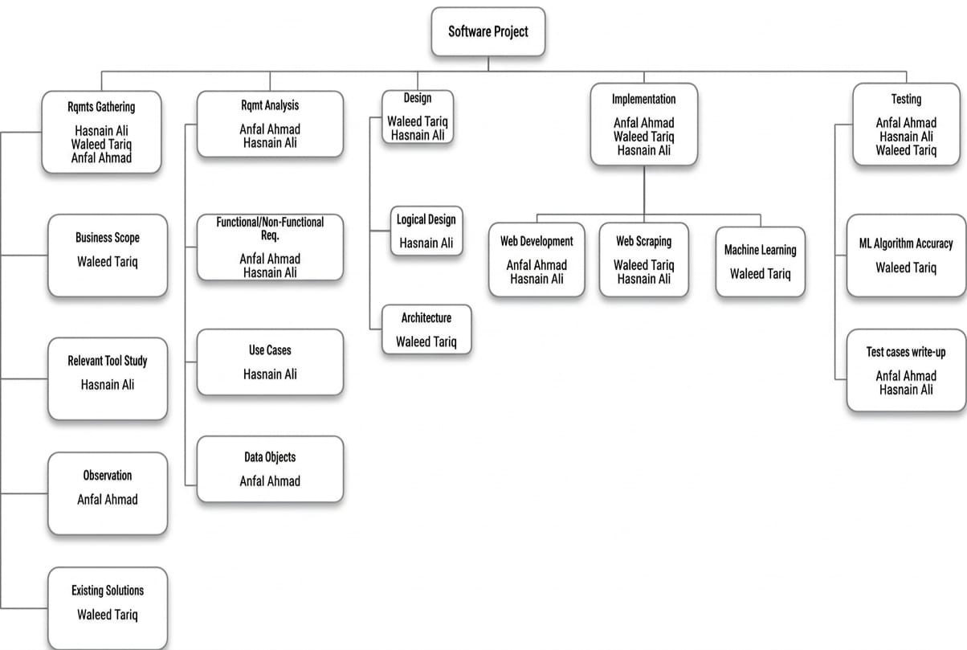
Figure 1.1: Project Work breakdown Structure

1.6. Project Time Line
The project time line has been assigned thoughtfully as the team acknowledges the various modules full potential towards their end.

Figure 1.2: Executive Cars Project Timeline
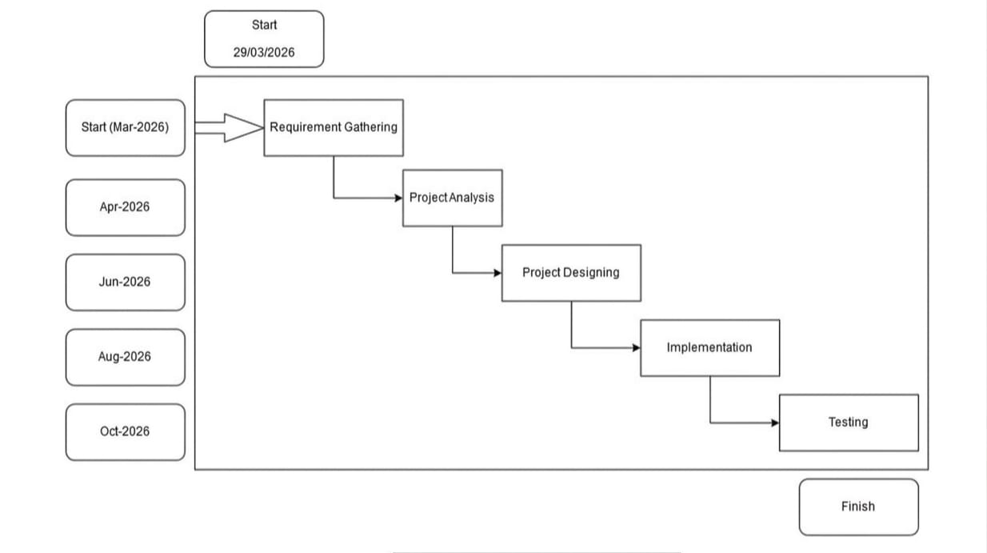

1.7. Conclusion
As this chapter concludes, the business aspect of the project and the technical aspect have been understood including the tech stack that will be used for developing the project. The project has been divided into 2 sections. The web development, both front-end and back-end, has been assigned to Muhammad Hasnain and Anfal Ahmad, whereas the Machine Learning modules has been assigned to Waleed Tariq.

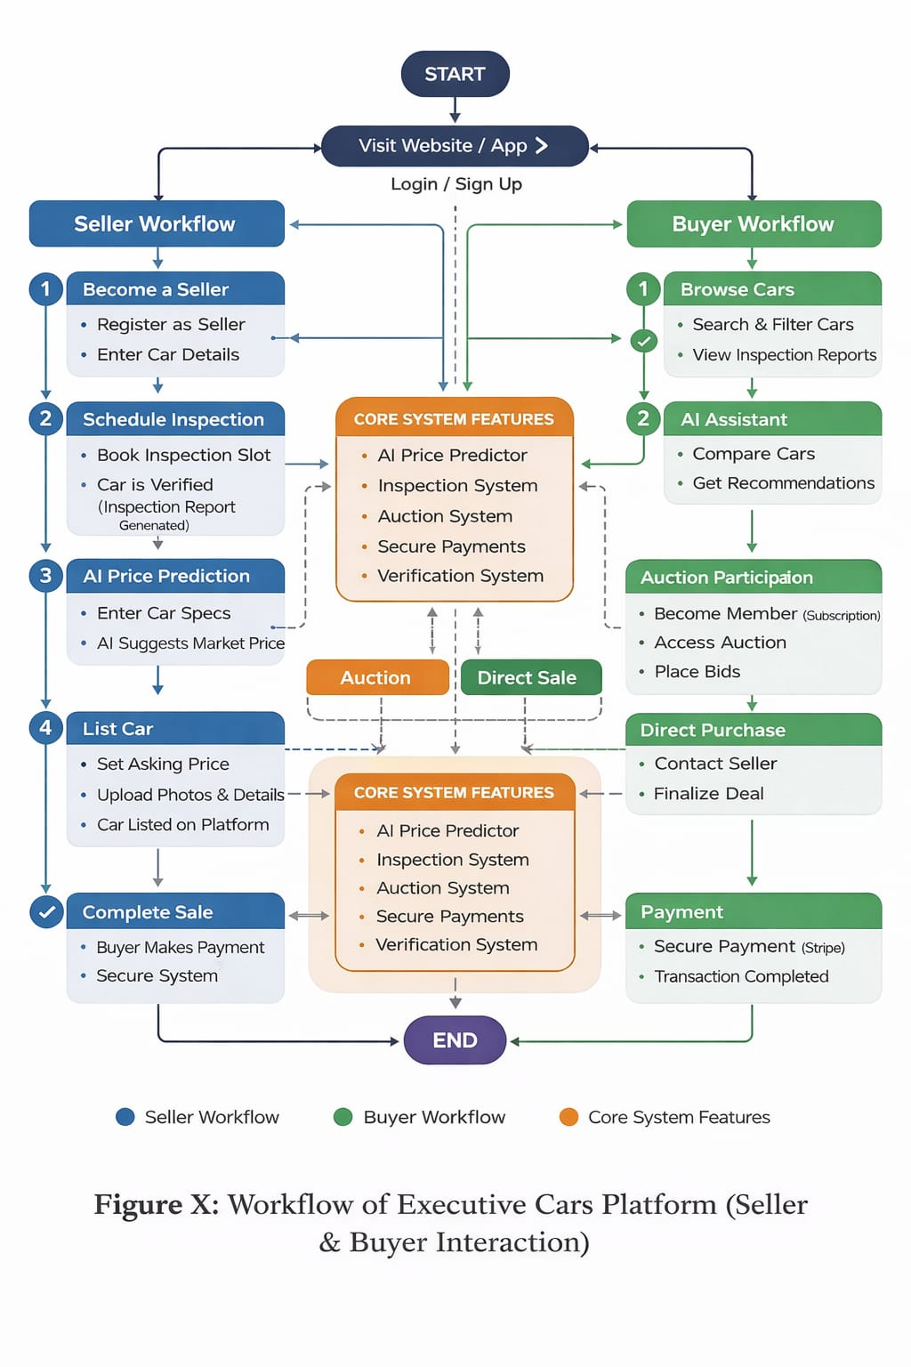
Figure 1.3 Project Workflow Diagram

Chapter 2

Requirement Specification and Analysis

The emphasis of this chapter is on identifying and analyzing the requirements for the Executive Cars platform, ensuring that the system is designed to provide a seamless and efficient car auction experience. By clearly defining the functional and non-functional requirements, this chapter lays the foundation for the system’s architecture and development process.
The Software Requirements Specification (SRS) is structured in a way that is understandable to both technical and non-technical stakeholders. It ensures that the system aligns with user needs while incorporating analytical models such as use case diagrams, system sequence diagrams, and domain models, which are essential for system design and implementation.
Through this structured approach, Executive Cars aims to create a transparent, secure, and scalable platform for buying and selling vehicles, leveraging AI-driven insights, digital auctions, and verified inspections to enhance user experience.

Requirement Specification:
Requirement specification involves continuous communication with stakeholders to gather expectations, resolve ambiguities, and document all key aspects of the system’s functionality. This process ensures that the system is designed to meet the needs of buyers, sellers, and administrators while maintaining performance, security, and usability.
The requirements define how the system should behave and what functionalities it must provide, ensuring that the Executive Cars platform operates efficiently and effectively. These specifications serve as a blueprint for development, guiding the implementation of features such as real-time bidding, car inspections, payment processing, and auction management.

2.1. Functional Requirements

The functional requirements for Executive Cars encompass a comprehensive set of features and functionalities aimed at providing a smooth and efficient user experience. These requirements are meticulously designed to meet user needs and expectations, ensuring clarity and alignment with their preferences.

Table 2.1: Functional Requirements
S. No. | Functional Requirement | Type | Status
1 | User can book car inspection slot | Core | Completed
2 | User can access car price predictor | Core | Completed
3 | User can access used cars | Core | Completed
4 | User can sign-up for auction platform | Core | Completed
5 | User can login to auction platform. | Core | Completed
6 | User can bid on cars. | Core | Completed
7 | User can view all details of cars | Core | Completed
8 | Search filter on used cars and auction platform | Intermediate | Completed
9 | User can logout of auction platform. | Core | Completed
10 | Admin can view used cars listings. | Intermediate | Completed
11 | Admin can login | Core | Completed
12 | Admin can update and delete cars on the website. | Intermediate | Completed
13 | Admin can upload cars on the used cars. | Core | Completed
14 | Admin can upload cars on the auction platform | Core | Completed
15 | Admin can view auction listings. | Core | Completed
16 | Admin can view top bidder details. | Core | Completed
17 | Admin can delete members | Intermediate | Completed
18 | Admin can view all inspection bookings. | Core | Completed
19 | Admin can logout | Core | Completed

2.2. Non-Functional Requirements

Non-functional requirements are crucial criteria ensuring our auction-based car selling website performs reliably and efficiently. They encompass aspects like performance, reliability, stability, scalability, availability, maintainability, and security. These requirements ensure the website operates smoothly, is userfriendly, and remains accessible and secure for both buyers and sellers.

Table 2.2: Functional and Non-Functional Requirement
S.  No. | Non-Functional Requirements | Category
1 | The system should give possible suggestions if the user enters wrong input. | Usability
2 | The system should keep and retrieve record correctly. | Reliability
3 | The system should verify the information correctly. | Security
4 | User authentication and authorization shall be implemented using JWT. | Security
5 | The user interface shall be intuitive and easy to navigate, with clear labeling and consistent design elements. | Usability

2.3.1 System Use Case Modelling

In our auction-based car selling website project, a use case outlines how users interact with the system to achieve specific goals. Each use case represents a scenario where the system responds to user actions, providing an efficient and satisfactory trading experience.

Figure 2.3.1: Buyer/Seller Use case Diagram
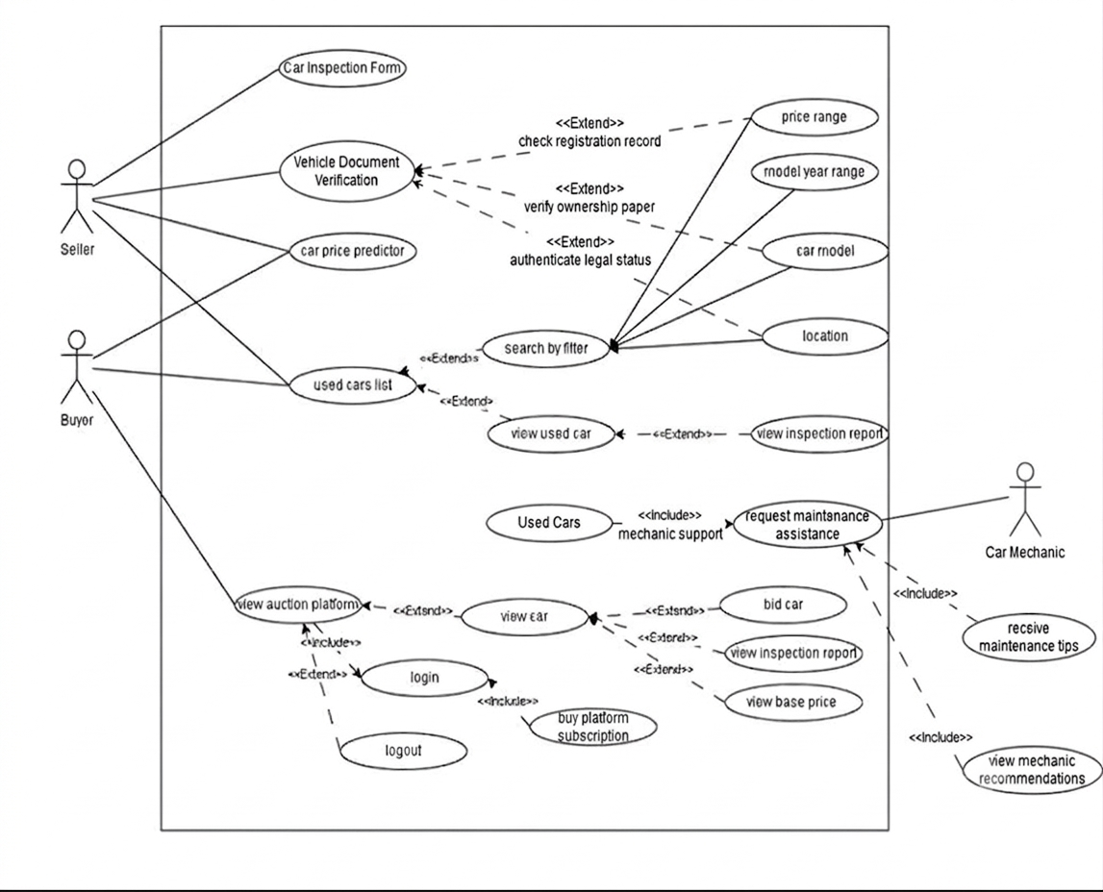

2.3.2 System Use Case Modelling

The admin manages the platform by uploading cars for auction and the used cars section, overseeing listings, and ensuring system functionality. Admins can log in, add new car listings, and delete cars when necessary, maintaining an organized and efficient marketplace.

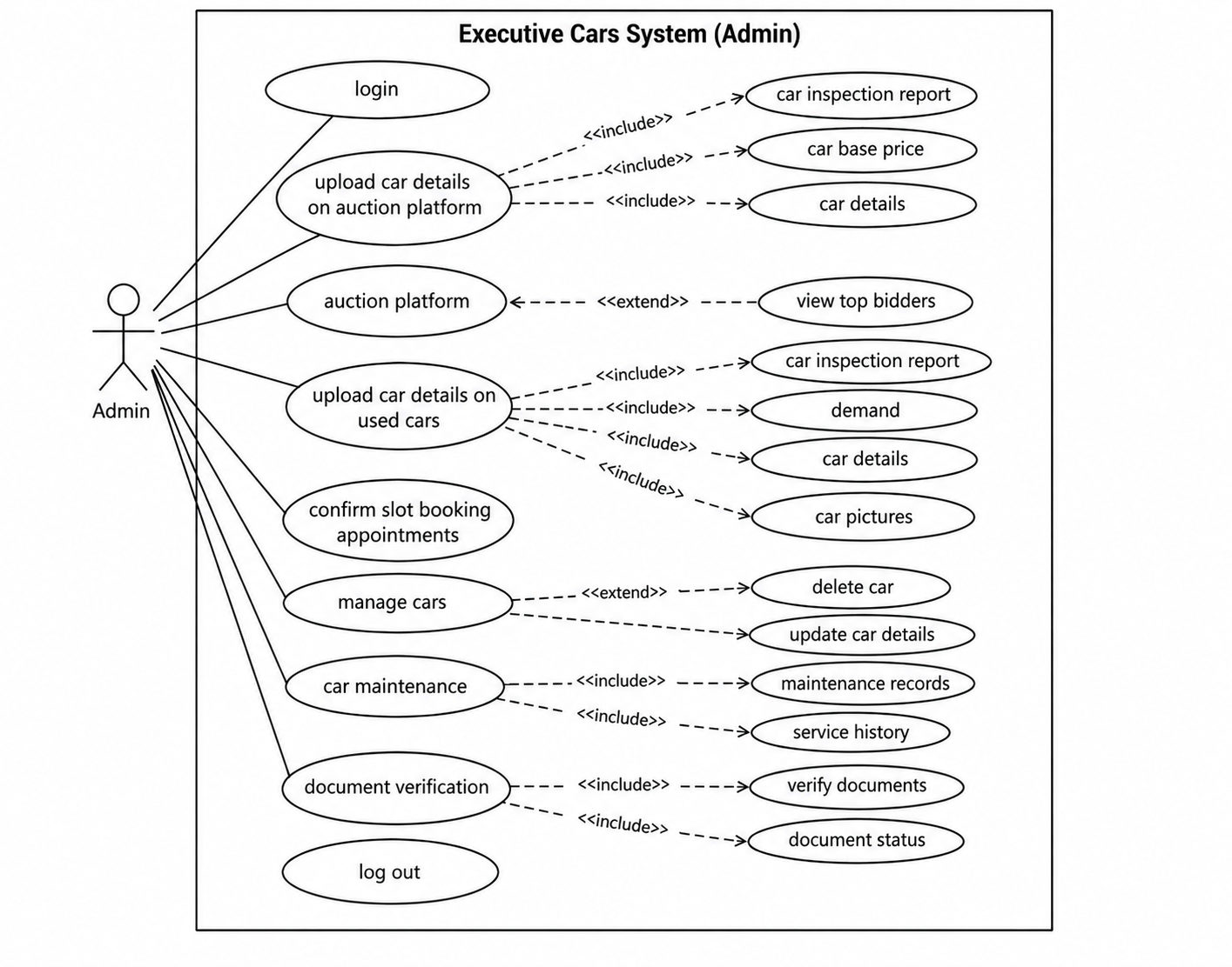
Figure 2.3.2: Admin Use case Diagram

Use Case 1: Become A Seller

Table 2.3.1: Use Case: Become A Seller
Use Case ID: | UC-01
Use Case Name: | Become A Seller
Created By: | Anfal Ahmad |  | Last Updated By: |  | Anfal Ahmad
Date Created: | 25/4/2026 |  | Last Revision Date: |  | 22/4/2026
Actors: |  | Seller
Description: |  | User can book an inspection slot for their car and get their car inspected by visiting our nearest branch.
Trigger: |  | Seller can click on Become A Seller
Preconditions: |  | Seller must open the page, and fill the form with all the required details and select an available date and push Book Now button.
Post conditions: |  | The request will be sent to the branch admin.
Normal Flow: |  | Seller |  | System
 |  | 1. Seller can click Become a Seller button to request for the inspection booking form.  3. Seller will fill the form and press the Book Now button. |  | 2. System will display form interface to the Seller.  4. System send form details to the admin and OTP will be sent to seller for verification.
Alternative Flows: |  | Seller cancels the current form
Exceptions: |  | 1.The system is not responding  2.The database is not responding  3.The Seller has not filled the form the correctly  4.The branch admin has not received the request from the system  5.OTP failed to deliver code

Use Case 2: Car Price Predictor

Table 2.3.2: Use Case: Car Price Predictor
Use Case ID: | UC-02
Use Case Name: | Car Price Predictor
Created By: | Anfal Ahmad |  | Last Updated By: |  | Anfal Ahmad
Date Created: | 25/4/2026 |  | Last Revision Date: |  | 22/4/2026
Actors: |  | User
Description: |  | User can check a price estimate of their car by providing details of their car.
Trigger: |  | User can click on Car Price Predictor
Preconditions: |  | User must open the page, and provide all car details push Submit button.
Post conditions: |  | ML model will predict car price and display a predicted price.
Normal Flow: |  | User |  | System
 |  | 1. User clicks Car Price Predictor option from the website.  3. User fills the form by providing company, model of their car. |  | 2. The system will provide the form.  4. System will send the parameters to the ML model which will return an estimate car price.
Alternative Flows: |  | User cancels the current form
Exceptions: |  | - The system is not responding  - The customer has not filled the form the correctly  - ML model predicts incorrectly  - API fails to fetch model result

Use Case 3: Used Cars

Table 2.3.3: Used Cars
Use Case ID: | UC-03
Use Case Name: | Used Cars
Created By: | Anfal Ahmad |  | Last Updated By: |  | Waleed Tariq
Date Created: | 25/4/2026 |  | Last Revision Date: |  | 22/4/2026
Actors: |  | User
Description: |  | User can click the Used Cars button to view all those cars that are unsold on the auction platform.
Trigger: |  | User can click on Used Cars
Preconditions: |  | User must open the page, and click on Used Cars
Post conditions: |  | User can view used cars list  User can view a car and all its details including inspection report and current price  User can apply filter to used cars list
Normal Flow: |  | User |  | System
 |  | 1. User clicks on Used Cars button from website.  3. User can click on car image link to request to view the car and its details.  5. User can click on View Inspection report.  7. User click on Filter |  | 2. System will provide list of cars  4. System provides with car details, images, current price and inspection report.  6. System displays inspection report  8. System displays interface with options
Alternative Flows: |  | User exits the current page.
Exceptions: |  | - The system is not responding  - Database is not responding

Use Case 4: Auction Platform

Table 2.3.4: Use Case: Auction Platform
Use Case ID: | UC-04

Use Case Name: | Auction Platform
Created By: | Waleed Tariq |  | Last Updated By: |  | Waleed Tariq
Date Created: | 25/4/2026 |  | Last Revision Date: |  | 22/4/2026
Actors: |  | Buyer
Description: |  | Buyer can buy auction platform subscription and then submit login details. After authentication auction platform will open where buyer will able to bid for any car.
Trigger: |  | Auction Platform Button
Preconditions: |  | Buyer who want to take part in the auction can sign up by filling the form and pay subscription fee.
Post conditions: |  | After signup buyer can login and access the auction platform
Normal Flow: |  | Buyer |  | System
 |  | 1. Buyer can click Auction Platform button to request for the auction platform.  3. If Buyer is already a member they can click already a member button and submit their login details, request to access the auction platform.  5. If the Buyer clicks on new member button, it will generate a request to become a member. |  | 2. System will provide interface with two options  4. System will check login details and then give access to the auction platform.  6. System will provide a form to become a new member.
 |  | 7. Buyer can enter his details and buy subscription. |  | 8. System will verify the payment and store details in database.
Alternative Flows: |  | Buyer cancels the current form
Exceptions: |  | 1.The system is not responding

Use Case 5: Admin Login

Table 2.3.5: Use Case: Admin Login
Use Case ID: | UC-05
Use Case Name: | Admin Login
Created By: | Anfal Ahmad |  | Last Updated By: |  | Waleed Tariq
Date Created: | 25/4/2026 |  | Last Revision Date: |  | 22/4/2026
Actors: |  | Admin
Description: |  | Admin can access their portal by providing email and password.
Trigger: |  | Admin button
Preconditions: |  | Admin will provide email and password and click on submit button
Post conditions: |  | Admin will be logged in to the portal
Normal Flow: |  | Admin |  | System
 |  | 1. Admin can click Admin button to request sign in.  3. Admin will fill the form by providing email and password.  5. Admin will be logged in to the admin panel |  | 2. System will provide admin login form  4. System will check credentials and allow admin to log in to the portal
Alternative Flows: |  | Admin cancels the current form
Exceptions: |  | 1.The system is not responding  2.Database is not responding  3.Admin has filled incorrect credentials

Use Case 6: Upload car details on auction platform

Table 2.3.6: Use Case: Upload car on auction platform
Use Case ID: | UC-06
Use Case Name: | Upload car details on auction platform
Created By: | Anfal Ahmad |  | Last Updated By: |  | Waleed Tariq
Date Created: | 25/4/2026 |  | Last Revision Date: |  | 22/4/2026
Actors: |  | Admin
Description: |  | Admin can upload inspected cars on the auction platform with their current base price
Trigger: |  | Upload car on auction platform button
Preconditions: |  | Admin will be logged in  Admin must have selected Upload car on auction platform
Post conditions: |  | Admin can upload car information and inspection report with their base price
Normal Flow: |  | Admin |  | System
 |  | 1. Admin will click Upload car on auction platform button to request to post the car information and inspection report.  3. Admin will click submit button to the form |  | 2.System will provide a form to admin to fill the car information and attach the inspection report  4.System will verify the form and process admins request
Alternative Flows: |  | Admin cancels the current form
Exceptions: |  | - The system is not responding  - Database is not responding  - Admin has filled incorrect credentials

Use Case 7: Upload car details on used cars

Table 2.3.7: Use Case: Upload car details on used cars
Use Case ID: | UC-07

Use Case Name: | Upload car details on used cars
Created By: | Anfal Ahmad |  | Last Updated By: |  | Waleed Tariq
Date Created: | 25/4/2026 |  | Last Revision Date: |  | 22/4/2026
Actors: |  | Admin
Description: |  | Admin can upload inspected cars on used cars with their current base price
Trigger: |  | Upload car details on used cars button
Preconditions: |  | Admin will be logged in  Admin must have selected Upload car on used cars.
Post conditions: |  | Admin can upload car information and inspection report with their base price
Normal Flow: |  | Admin |  | System
 |  | 1. Admin can click Upload car details on used cars to request to post the car information and inspection report. |  | 2. System will provide a form to admin to fill the car information and attach the inspection report
Alternative Flows: |  | Admin cancels the current form
Exceptions: |  | - The system is not responding  - Database is not responding  - Admin has filled incorrect credentials

Use Case 8: Manage Cars

Table 2.3.8: Use Case: Manage Cars
Use Case ID: | UC-8
Use Case Name: | Manage Cars
Created By: | Waleed Tariq |  | Last Updated By: |  | Waleed Tariq
Date Created: | 25/4/2026 |  | Last Revision Date: |  | 22/4/2026
Actors: |  | Admin
Description: |  | Admin will be able to delete and update cars which are uploaded by admin on both auction and used cars platform.
Trigger: |  | Manage Cars
Preconditions: |  | Admin will be logged in  Admin must have selected edit or delete option.
Post conditions: |  | Admin can delete or update any car which are uploaded by admin.
Normal Flow: |  | Admin |  | System
 |  | 1. Admin can click edit or delete button to request the interface. |  | 2. System will provide the interface with all the cars uploaded by the admin.
 |  | 3. Admin can click on any car to update or delete that car.
Alternative Flows: |  | Admin cancels the current form
Exceptions: |  | 1.The system is not responding  2.Database is not responding  3.Admin has filled incorrect credentials

Use Case 9: Admin Logout

Table 2.3.9: Use Case: Admin Logout
Use Case ID: | UC-9
Use Case Name: | Admin Logout
Created By: | Waleed Tariq |  | Last Updated By: |  | Waleed Tariq
Date Created: | 25/4/2026 |  | Last Revision Date: |  | 22/4/2026
Actors: |  | Admin
Description: |  | Admin can logout
Trigger: |  | Logout button
Preconditions: |  | Admin must be logged in.
Post conditions: |  | Admin is successfully logged out and redirected to the login page.
Normal Flow: |  | Admin |  | System
 |  | 1. Admin can click logout button |  | - System will logout admin from admin panel.  - System will redirect to admin login page
Alternative Flows: |  | Admin cancels the current form
Exceptions: |  | 1.The system is not responding  2.Database is not responding

2.4. System Sequence diagrams

System Sequence Diagrams (SSDs) illustrate how users interact with our auction-based car selling platform to complete tasks. They outline user actions, system responses, and data flow, providing a clear understanding of platform functionality for developers.

SSD-01:

Figure 2.4.1: SSD (Become A Seller)

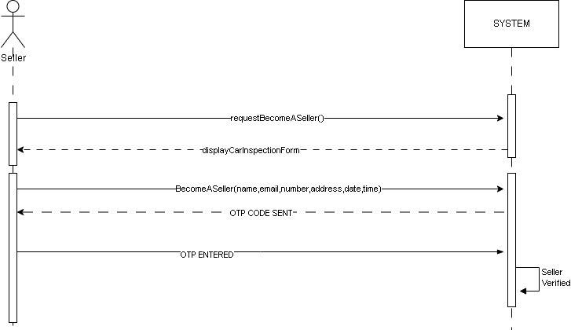

SSD-02:

Figure 2.4.2: SSD (Become A Member)

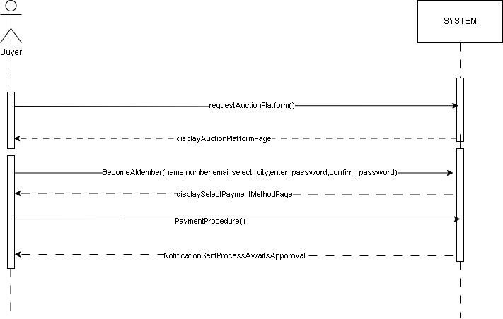

SSD-03:

Figure 2.4.3: SSD (Already A Member)

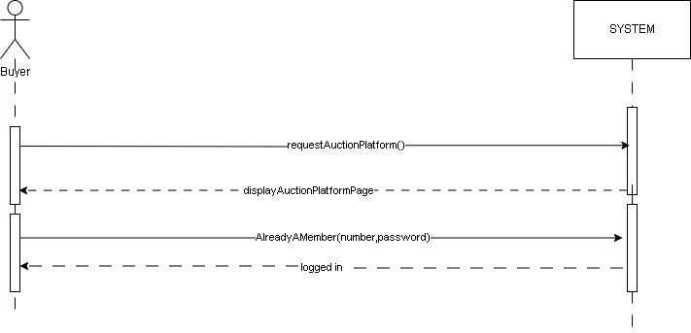

SSD-04:

Figure 2.4.4: SSD (Auction Platform)

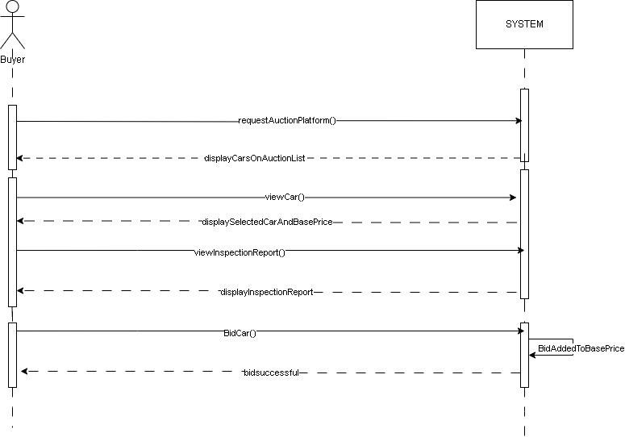

SSD-05:

Figure 2.4.5: SSD (Car Price Predictor)

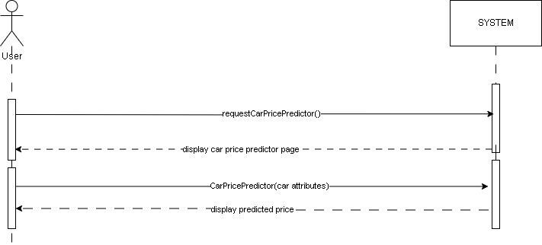

SSD-06:

Figure 2.4.6: SSD (Used Cars)

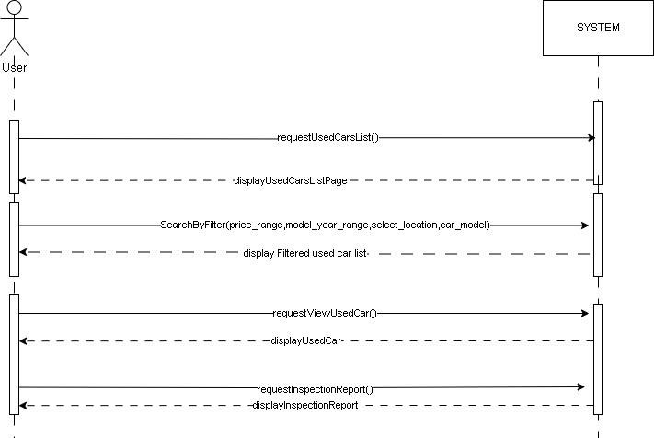

SSD-07:

Figure 2.4.7: SSD (Admin login)

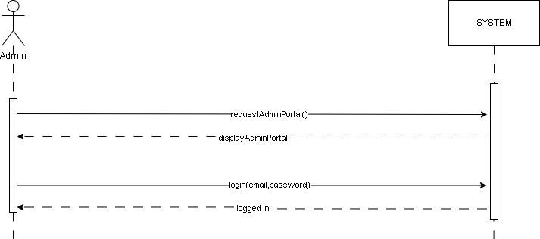

SSD-08:

Figure 2.4.8: SSD (Admin Add Car Auction Platform)

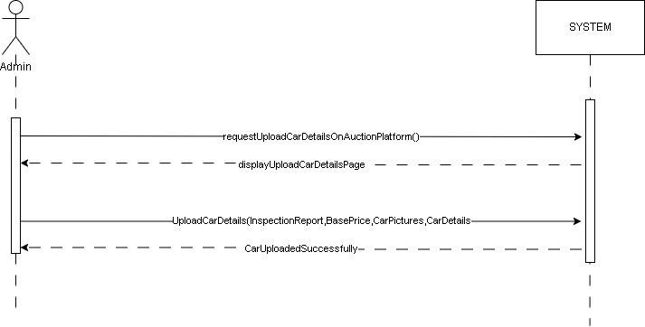

SSD-9:

Figure 2.4.9: SSD (Admin Add Car Details On Used Cars)

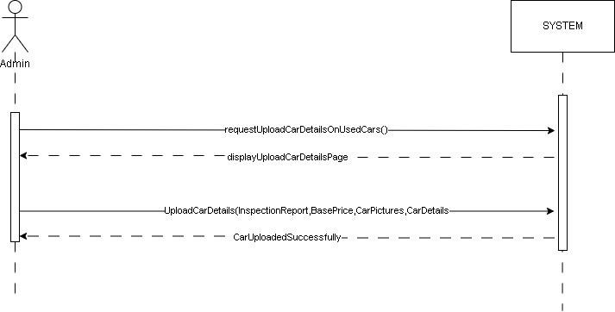

SSD-10:

Figure 2.4.10: SSD (Admin Manage Cars)

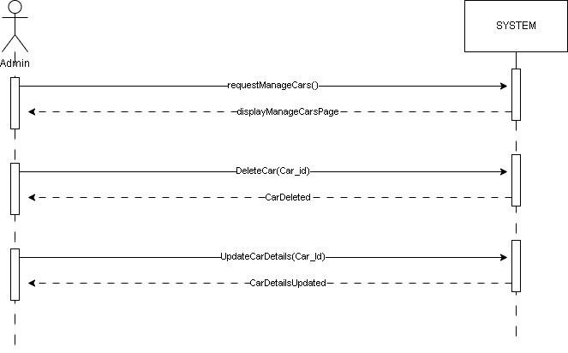

SSD-11:

Figure 2.4.11: SSD (Admin Log out)

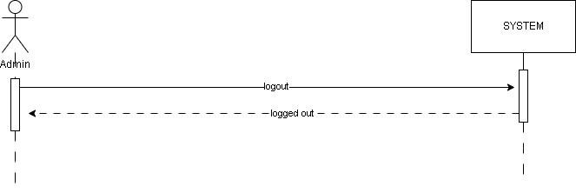

2.5. Domain Model

The domain model provides an overview of key entities and their relationships within the auction-based car selling website. It defines users (buyers, sellers, and admin), cars, payments, and administrative functions, serving as a foundation for system development.

Figure 2.5: Domain Model
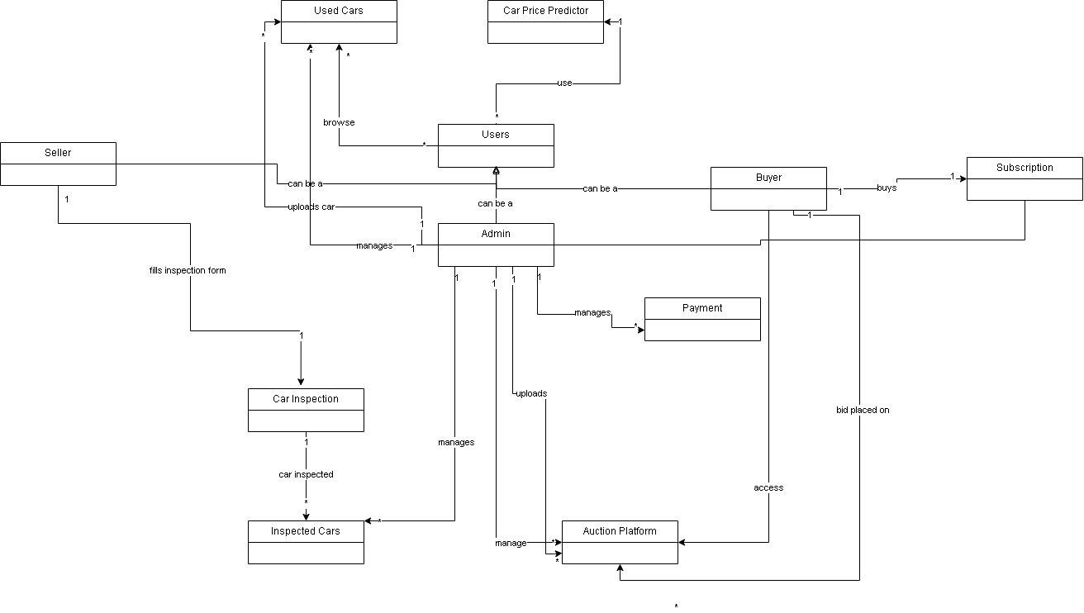

.

2.6. Conclusion

This chapter provided a comprehensive analysis of the requirement specifications for our auction-based car selling website, Executive Cars. We established a clear domain model, identifying key entities such as buyers, sellers, admins, and cars, along with their interactions. System Sequence Diagrams (SSDs) illustrated user-system interactions, aiding developers in understanding platform functionality. The use case modelling detailed various system functionalities, including buying, selling, and administrative tasks, ensuring a seamless user experience. Additionally, we outlined functional and nonfunctional requirements, ensuring the platform's reliability, security, and scalability. This structured analysis serves as a foundation for the system's development, guiding implementation and future enhancements.

Chapter 3

System Design

The purpose of this chapter is to outline the design and architectural structure of the Executive Cars auction platform. Effective system design ensures that the software meets its functional requirements while maintaining efficiency, scalability, and security. This chapter provides insights into how various components interact, ensuring smooth user operations such as bidding, listing cars, membership management, and inspection bookings.
A well-defined architecture is essential for maintaining system integrity and simplifying future enhancements. The design follows a layered approach, dividing the system into presentation, business logic, data access, and infrastructure layers to achieve modularity and maintainability.
To effectively communicate the system architecture, two key views are considered:
· Structural View: This represents the major software components and their relationships. The artifacts in this category include:
- System Architecture Diagram
- Class Diagram
- Entity Relationship Diagram (ERD)
· Behavioral View: This illustrates how different components and users interact within the system. The artifacts in this category include: o Sequence Diagram o System Workflow and Interaction Model
At a high level, the system design covers:
  - Software Architecture Overview: A breakdown of key system components, their interactions, and responsibilities.
  - Functional and Non-Functional Requirements Alignment: Ensuring that the architecture supports the necessary performance, security, and scalability constraints.
  - Deployment Strategy: The underlying hardware and software infrastructure, including database management, API gateways, and server configurations.
  - Design Justification: An explanation of architectural choices, trade-offs, and adherence to best practices in system design.
Additionally, design patterns play a significant role in ensuring reusability, maintainability, and efficiency. For instance, the MVC (Model-View-Controller) pattern is followed for structuring the application, while database interactions rely on best practices suited for MongoDB's document-oriented model.
By structuring the design in this manner, the Executive Cars platform ensures an intuitive user experience, smooth backend processes, and a robust system foundation. The following sections provide a detailed breakdown of each component, including UI design, system diagrams, and infrastructure considerations.

3.1. Software Architecture

Software architecture defines the structural organization of a system, composed of various components working together to fulfill specific functionalities. For the Executive Cars auction platform, the architecture is designed to ensure scalability, security, and maintainability, while enabling seamless bidding, car listings, membership management, and inspection bookings.
To achieve an effective architecture, several key principles have been followed, focusing on modularity, performance, and flexibility. The major decisions made in structuring this architecture include:

Determining the Application Type:
The system is designed as a web-based auction platform, utilizing a MERN (MongoDB, Express.js, React, Node.js) stack to ensure an interactive user experience and smooth backend processing.

Determining the Deployment Strategy:
- The backend is hosted on Digital Ocean, ensuring reliable server management.
- The frontend is deployed on Hostinger, ensuring accessibility and performance.
- MongoDB Atlas is used for database management, providing a scalable and secure cloud-based storage solution. o Stripe API is integrated for handling membership payments.

Determining the Appropriate Technologies:
- Frontend: React with Tailwind CSS for an intuitive and responsive UI.
- Backend: Node.js with Express.js to handle server-side logic and API endpoints.
- Database: MongoDB Atlas for flexible, document-oriented data management.
- Authentication: JWT-based authentication system for user security.
- Payment Gateway: Stripe for secure transaction processing.

Determining the Quality Attributes:
- The system is designed to uphold:
- Scalability: The architecture supports an increasing number of users and auctions without performance degradation.
- Security: JWT authentication, data validation, and access control measures are implemented to prevent unauthorized access.
- Maintainability: A modular design with clear separation of concerns enables easier updates and feature extensions.
- Performance: Optimized database queries and efficient API request handling enhance response times.

Determining the Crosscutting Concerns:
- Logging and Monitoring: Server-side logs track user activity and system performance for debugging and maintenance.
- Error Handling: Graceful error management ensures smooth user interactions without unexpected crashes.
- Data Backup and Recovery: MongoDB Atlas provides automatic backups to prevent data loss.
- Session Management: Secure handling of user sessions ensures seamless authentication and authorization.
This architecture ensures that the Executive Cars auction platform delivers a robust, high-performance, and user-friendly experience while maintaining security and extensibility. The following sections provide an in-depth breakdown of each architectural layer.

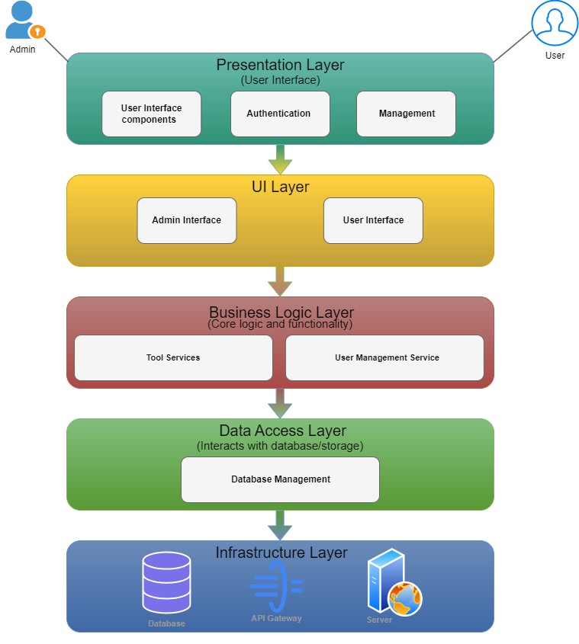
Figure 3.1: Software Architecture Diagram

3.1.1. Presentation Layer

Components:
User Interface components include web pages, forms, buttons, and dashboards for users and admins.
Responsibilities:

- Rendering the user interface for seamless interaction.
- Managing authentication & session handling for members and admins.
- Handling user profile management, including updates and settings.
- Managing membership payments, allowing users to view, pay, and manage their
subscriptions via Stripe integration.
- Auction listing management, enabling users to upload, delete, and organize car
listings.
- Booking system integration, allowing users to schedule inspection slots with OTP
verification.
- Admin dashboard functionality, supporting member management, auction approvals,
and car listing oversight.

3.1.2. UI Layer

Components:
- Admin Interface
- User Interface
Responsibilities: Providing interfaces tailored for administrators and regular users.
Admin Interface:
- Accessible only by administrators.
- Manages system configurations, user accounts, auction listings, inspection bookings, and content moderation.
User Interface:
- Accessible by registered members and visitors.
- Allows users to sign up, manage profiles, pay for membership, book inspections, list cars for auction, and browse available listings.

3.1.3. Business Logic Layer
Components:
- Auction Services: Car Price Prediction, Auction Bidding, Inspection Booking, Used Car Listings.
- User Management Services: Buyer Registration, Membership Subscription, Payment Processing.
- Admin Management Services: Car Upload & Removal, Auction Moderation, Inspection Report Management.
Responsibilities:
- Auction Services: Handles core auction functionalities such as bidding, car price estimation, and scheduling inspections.
- User Management Services: Manages user authentication, profile details, membership subscriptions, and payment transactions.
- Admin Management Services: Enables admins to upload, manage, and remove auction and used car listings while overseeing inspection reports.

3.1.4. Data Access Layer

Components:
- Database Management: Handles User Data, Auction Data, Booking Data, and Payment Data.
Responsibilities:
- Managing database interactions and queries for accessing and manipulating user profiles, auction listings, inspection bookings, and membership subscriptions.

3.1.5. Infrastructure Layer

Components:
- Database (MongoDB Atlas) · API Gateways
- Server (Digital Ocean).
Responsibilities:
- Database: Stores and manages data related to users, auctions, inspections, payments, and car listings.
- API Gateways: Serve as entry points for external clients to interact with the system’s APIs securely.
- Server (Digital Ocean): Hosts and runs the backend application logic, handles client requests, processes payments via Stripe, and manages real-time interactions.
- Frontend (Hostinger): Hosts the user interface, ensuring accessibility and responsiveness for end users.

3.2. Class Diagram

The class diagram (Fig. 3.2) provides an overview of the Executive Cars website, illustrating system classes, objects, and their relationships. It models the data structure, aids in system design, and enhances stakeholder understanding.

Figure 3.2: Class Diagram
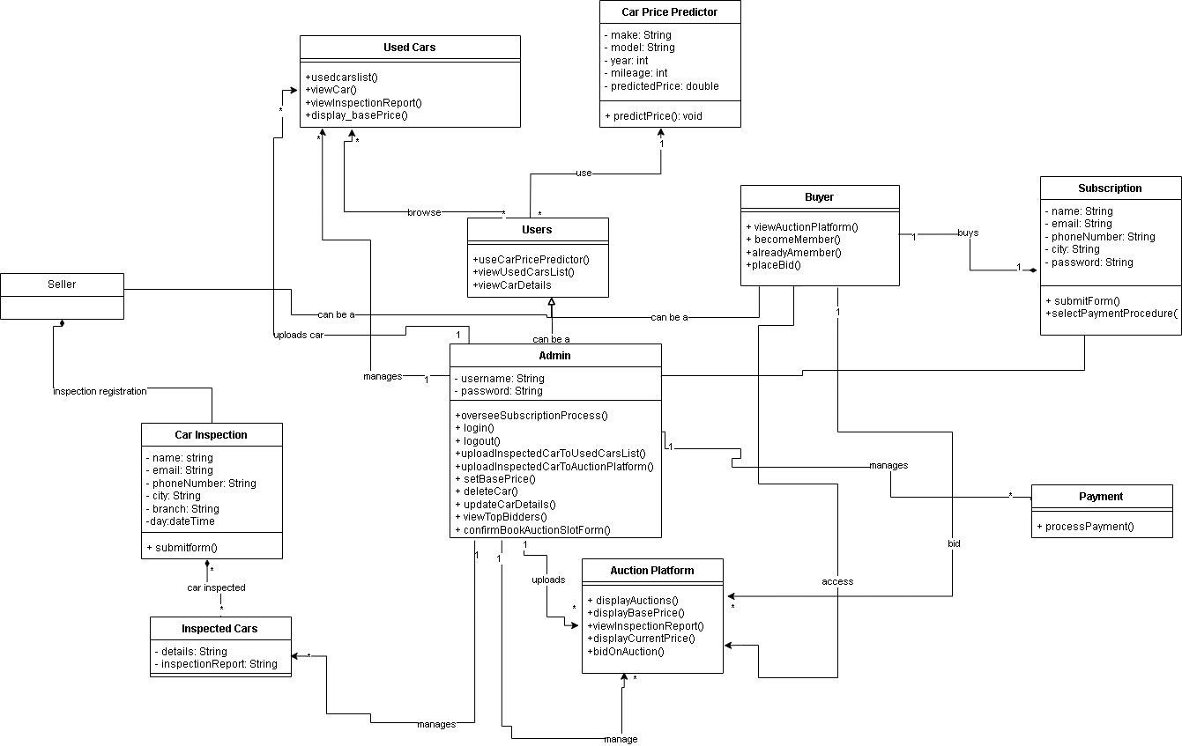

3.3 Sequence Diagram

Sequence Diagram in our auction platform shows interactions between buyers, sellers, admins, and the system. It outlines how users complete tasks like bidding, listing cars, and processing payments, helping developers understand workflows and system integration.

SD-01: Admin Login

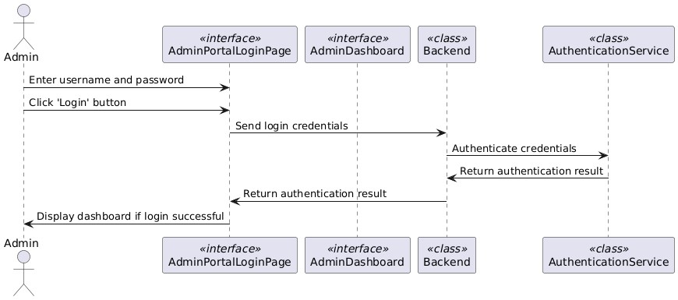
Figure 3.3.1: SD-01: Admin Login

SD-02: Admin Logout

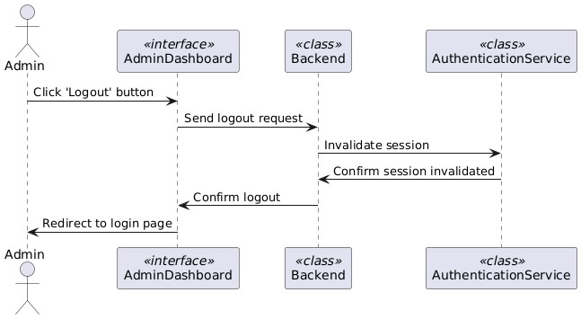
Figure 3.3.2: SD-02: Admin Logout

SD-03: Become A Seller

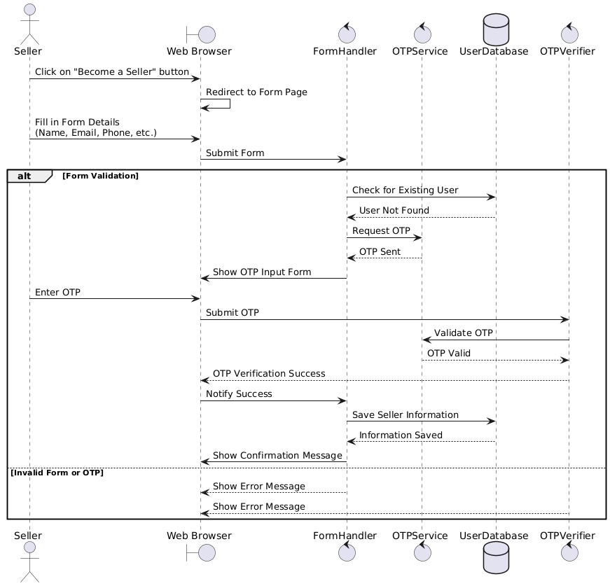
Figure 3.3.3: SD-03: Become a Seller

SD-04: Used Cars

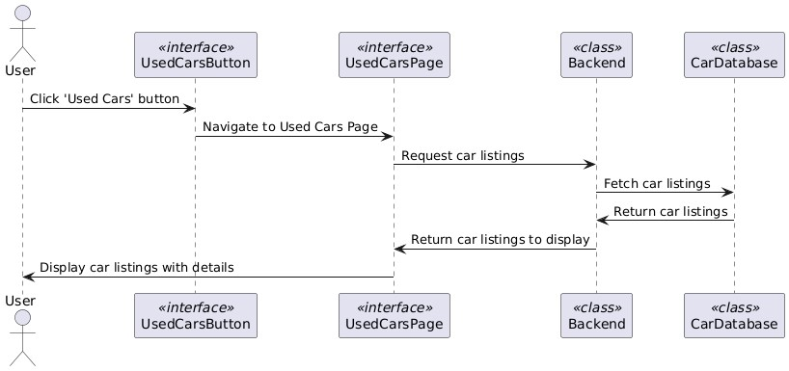
Figure 3.3.4: SD-04: Used Cars

SD-05: Car Price Predictor

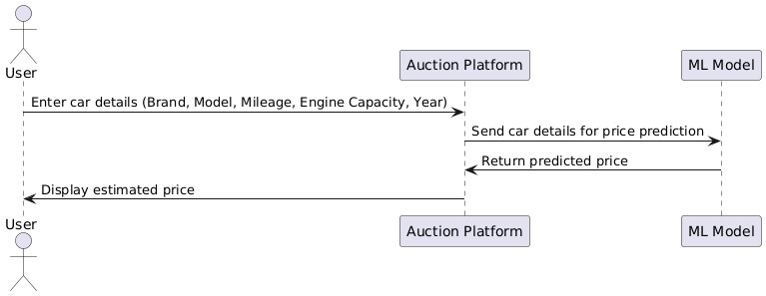
Figure 3.3.5: SD-05: Car Price Predictor

SD-06: Admin Upload Car Details

Figure 3.3.6: SD-06: Admin Upload Car Details
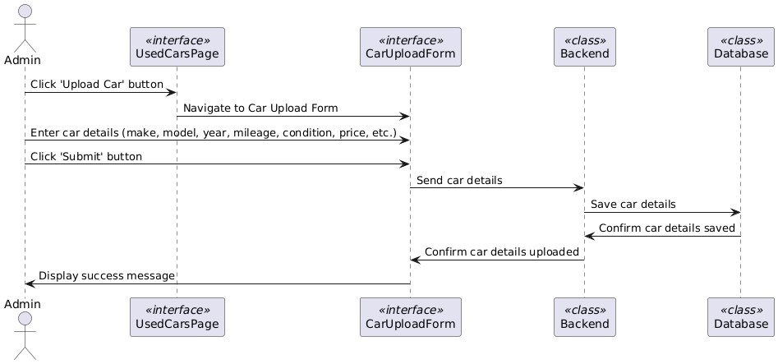

SD-07: Become A Member

Figure 3.3.7: SD-07: Become A Member
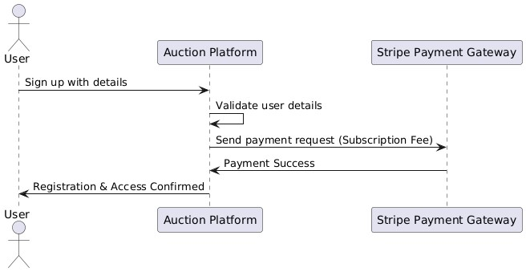

SD-08: Auction Platform Bidding

Figure 3.3.8: SD-08: Auction Platform Bidding
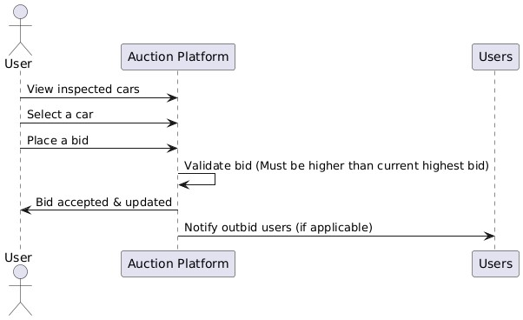

SD-09: Auction End

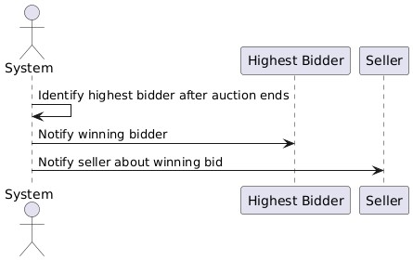
Figure 3.3.9: SD-09: Auction Platform Auction End

SD-10: Search Filter

Figure 3.3.10: SD-10: Search Filter
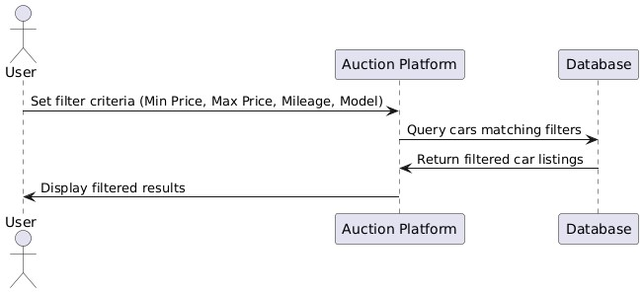

SD-11: Admin View & Deletion

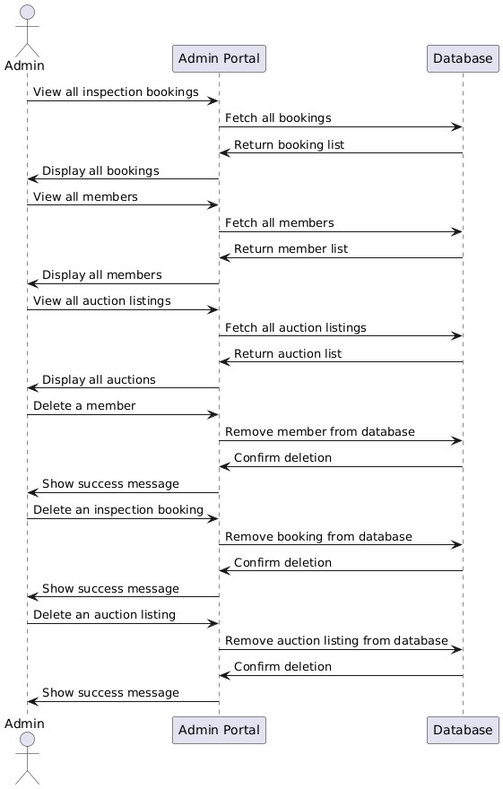
Figure 3.3.11: SD-11: Admin View & Deletion

3.4. Entity Relationship Diagram / Database Schema

Designing an Entity Relationship Diagram (ERD) for our auction platform helps model data structure and relationships. Since MongoDB is document-oriented, it uses embedding and referencing to represent entity connections efficiently.

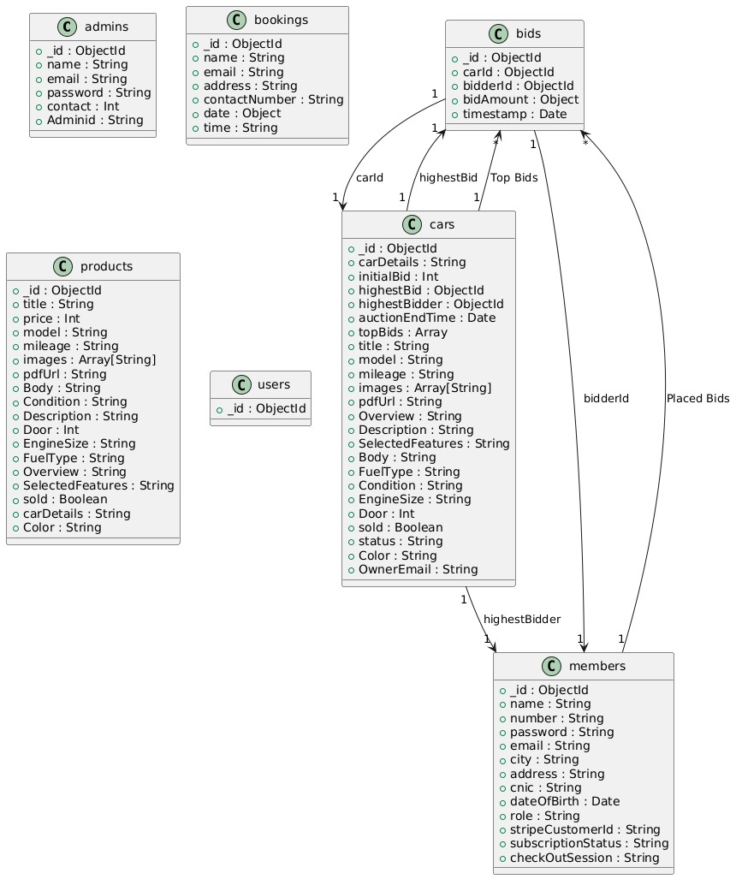
Figure 3.4: Entity Relationship diagram & Database Schema

3.5. User Interface Design

User Interface (UI) Design is a pivotal aspect of our auction-based car selling platform, focusing on anticipating users' needs and ensuring that the interface provides easy access to essential functionalities. UI design encompasses various principles from interaction design, visual design, and information architecture to create a seamless and intuitive user experience.

Home Page: Header:

Figure 3.5.1 Home Page: Header:
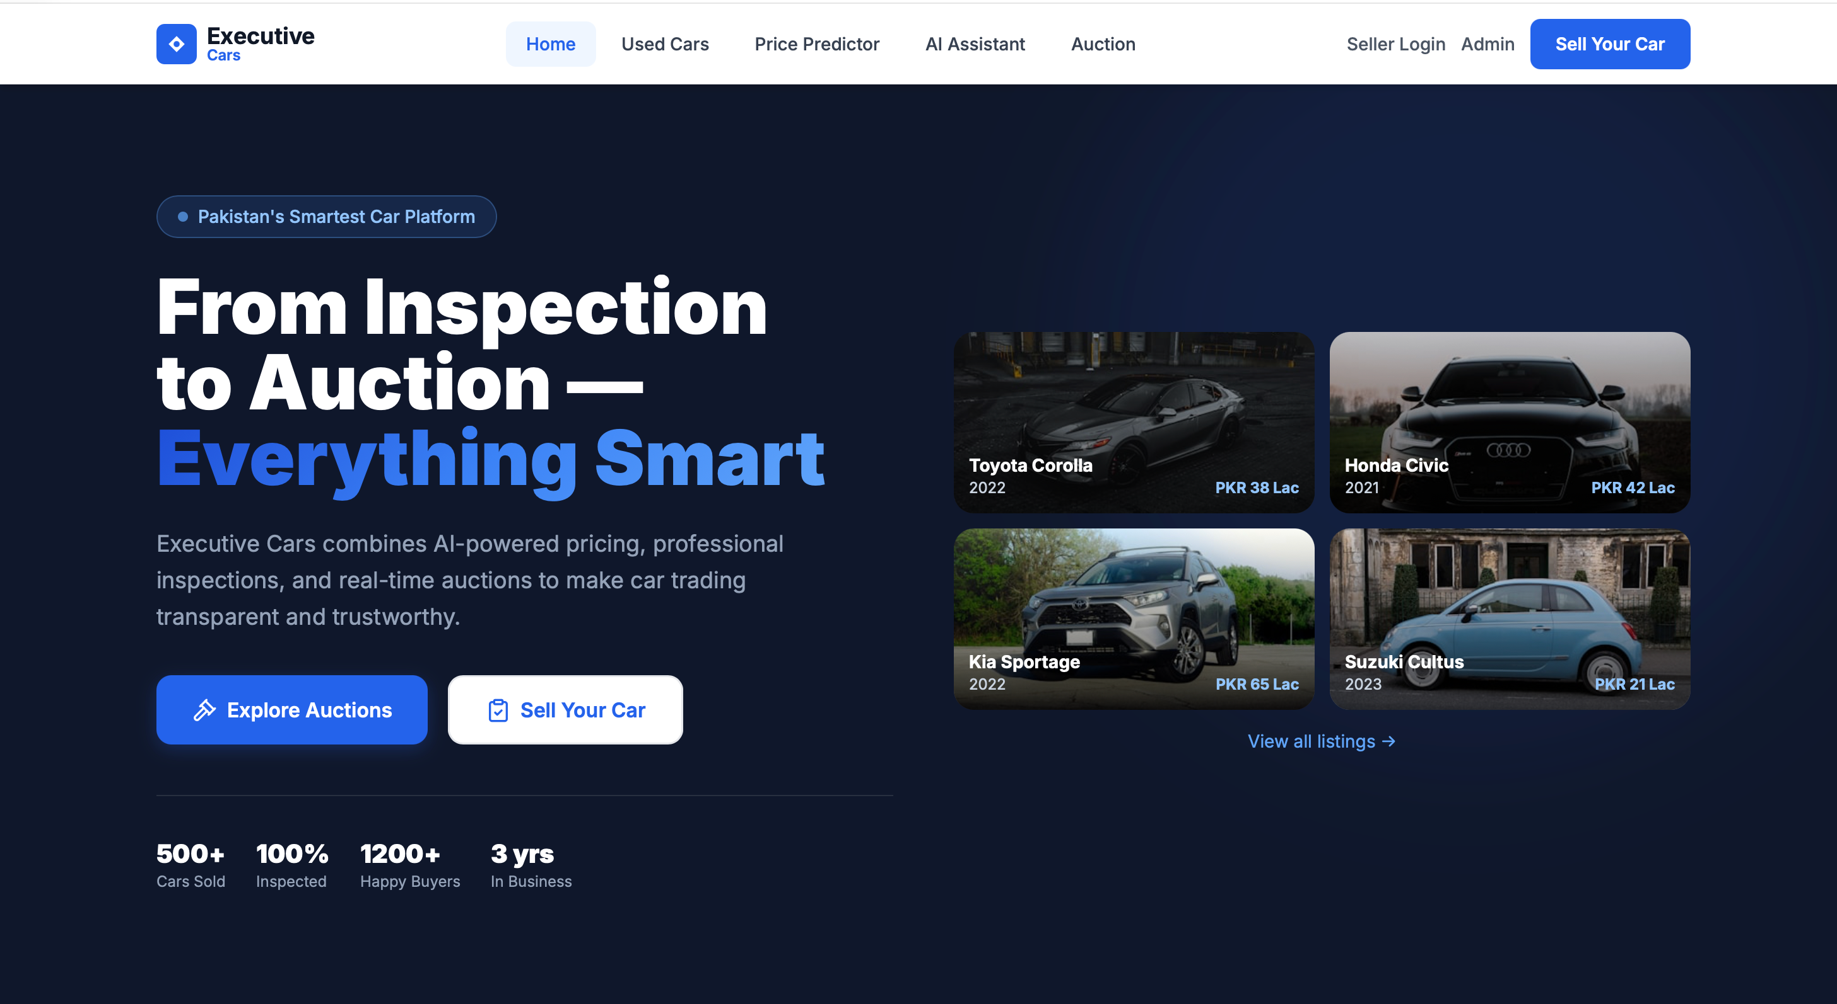

Home Page: Our Services:

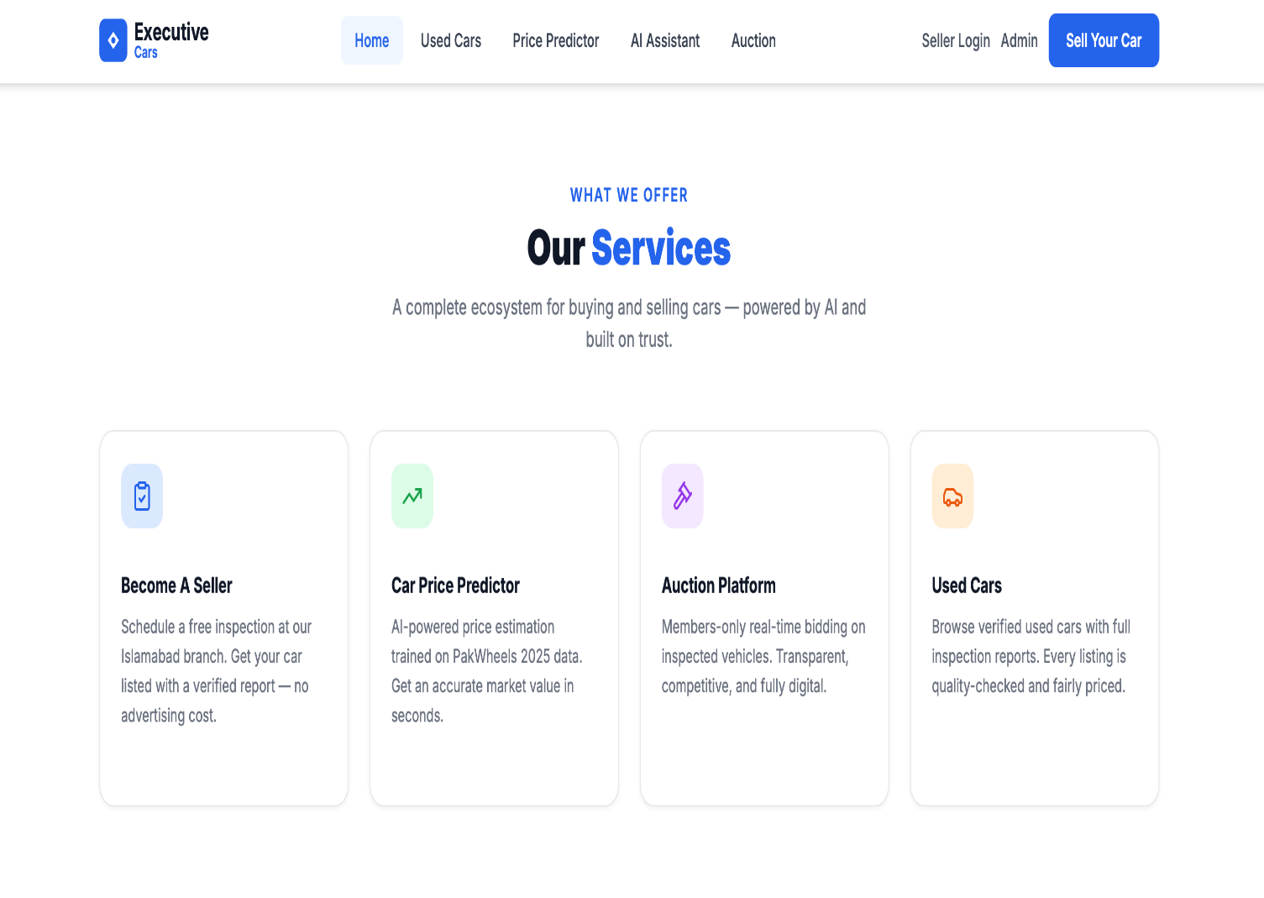
Figure 3.5.2 Home Page: Our Services:

Home Page: About Us:

Figure 3.5.3 Home Page: About Us:
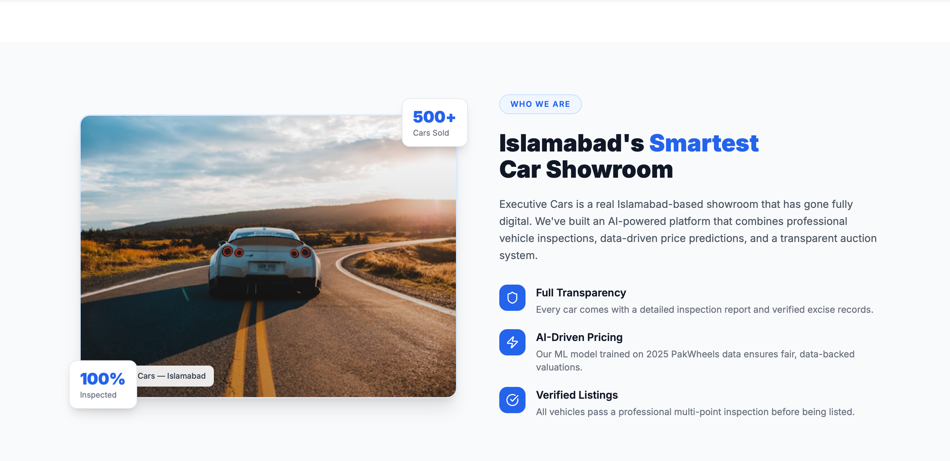

Home Page: Footer:

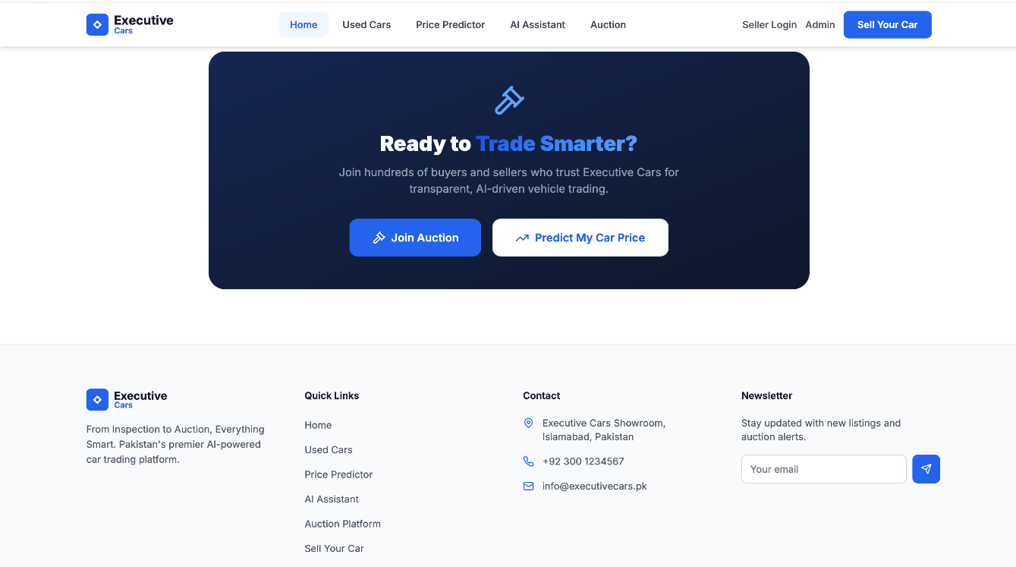
Figure 3.5.4 Home Page: Footer:

Become A Seller Page:

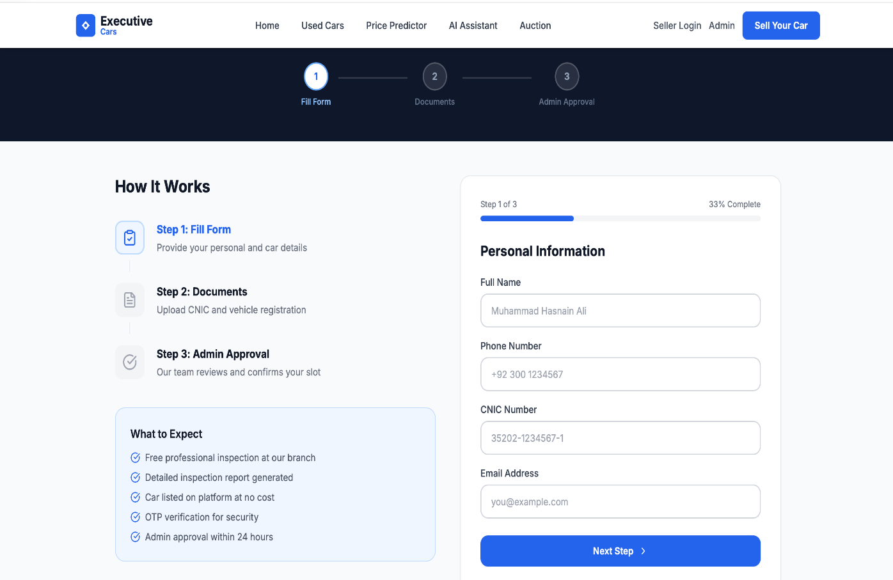
Figure 3.5.5 Become A Seller Page:

Used Cars Page:

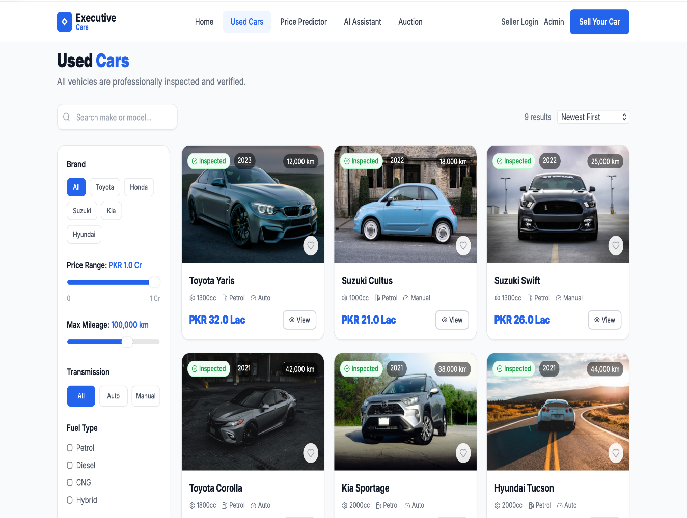
Figure 3.5.6 Used Cars Page:

Car Price Predictor:

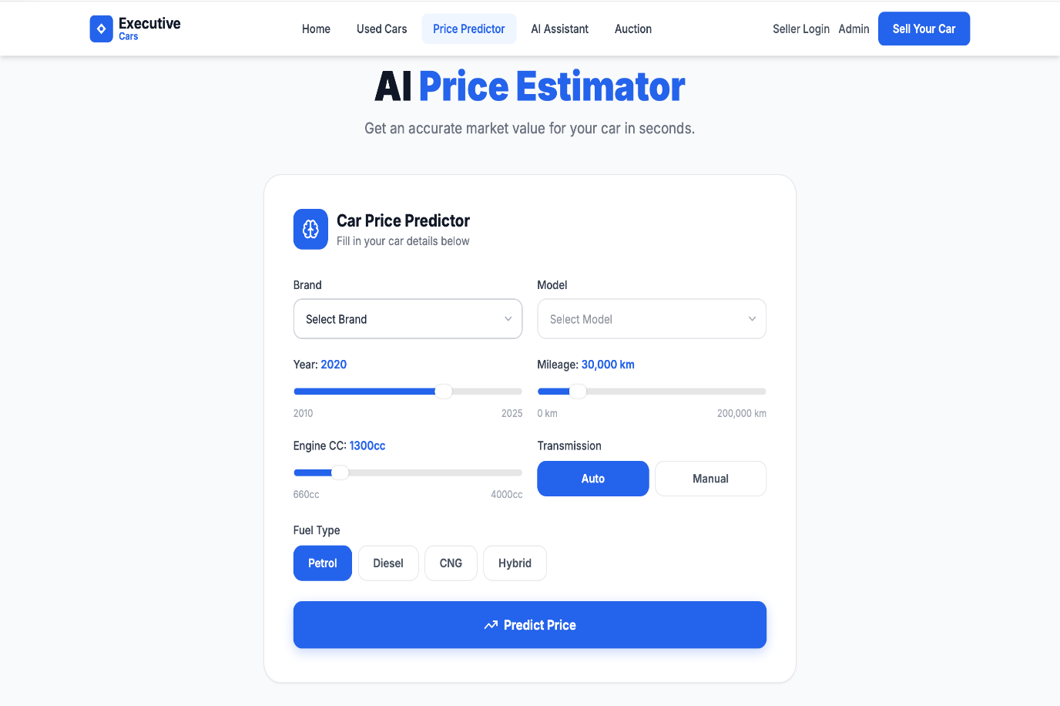
Figure 3.5.7 Car Price Predictor:

AI Car Assistant:

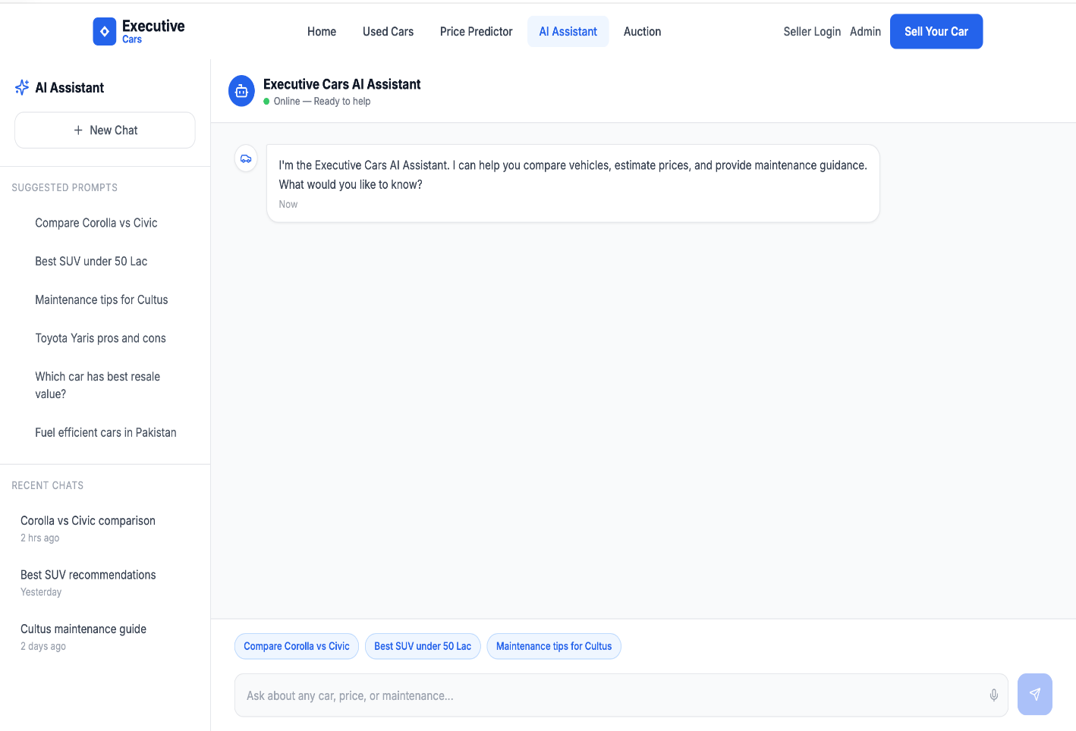
Figure 3.5.8 AI Car Assistant:

Auction Platform: Member

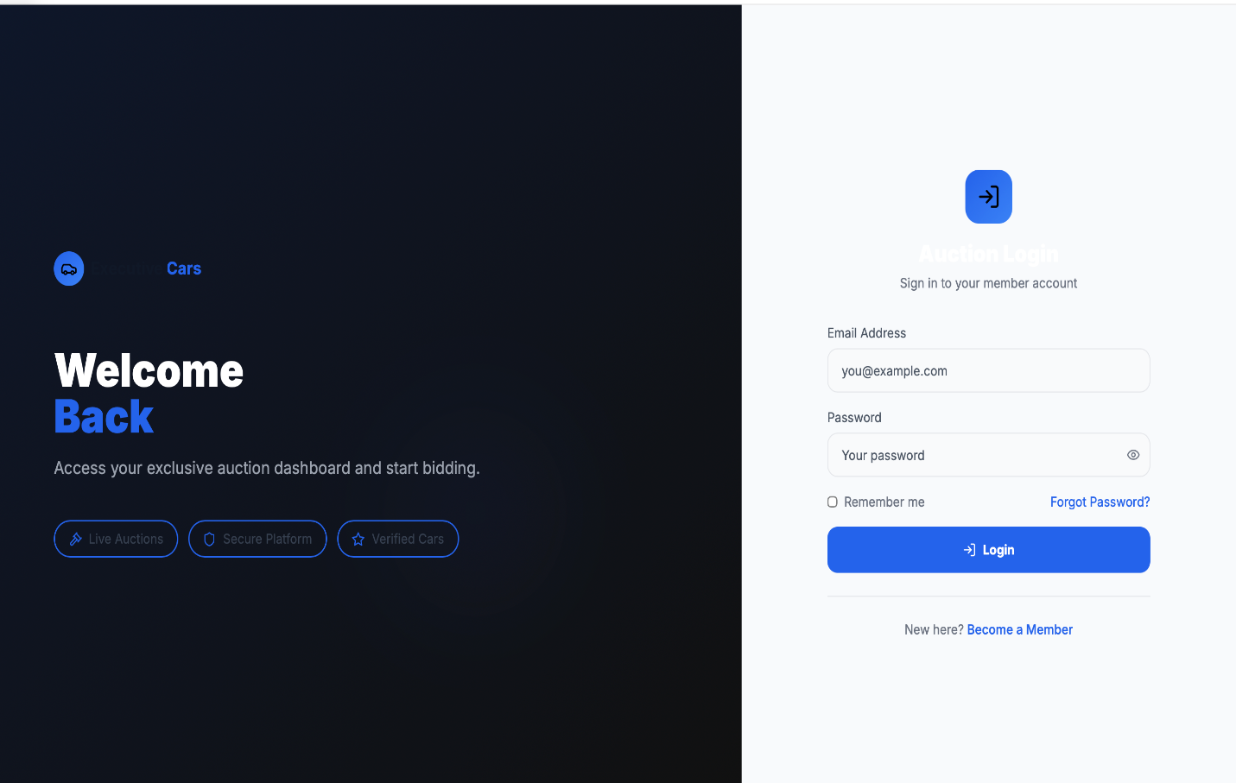
Figure 3.5.9 Auction Platform: Member

Auction Platform: Sign-up:

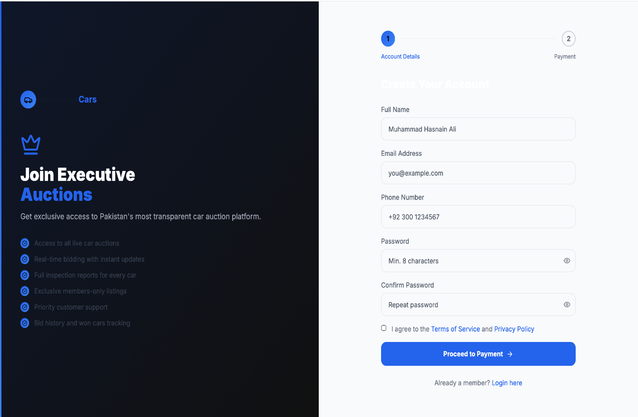
Figure 3.5.10 Auction Platform: Sign-up:

Auction Platform: Login:

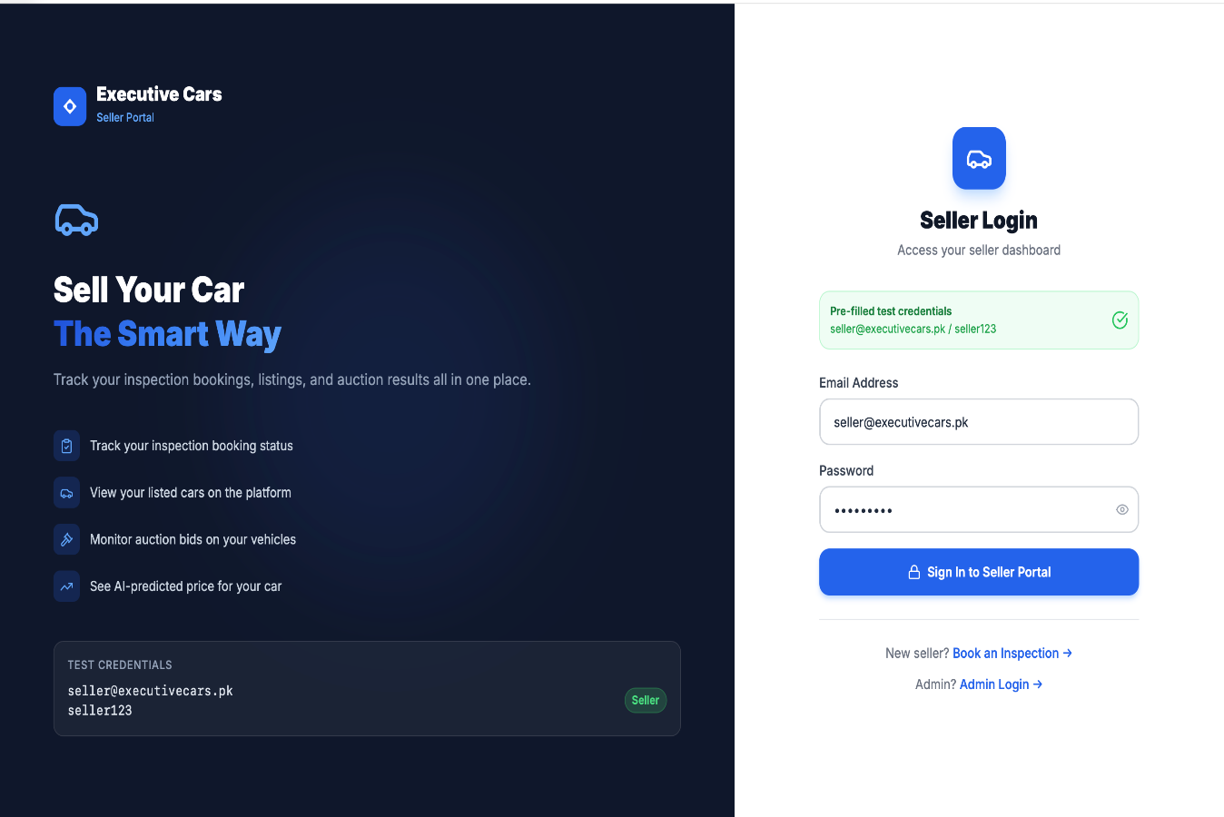
Figure 3.5.11 Auction Platform: Login:

Auction Platform: Dashboard:

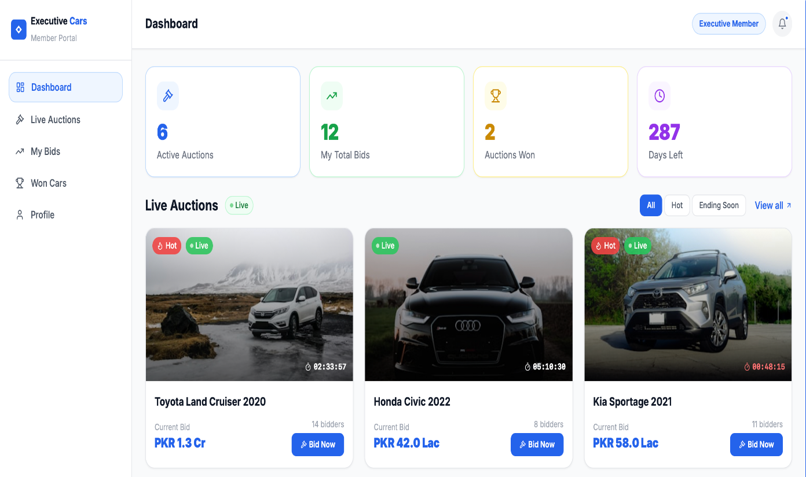
Figure 3.5.12 Auction Platform: Dashboard:

Auction Platform: Car Detail Page:

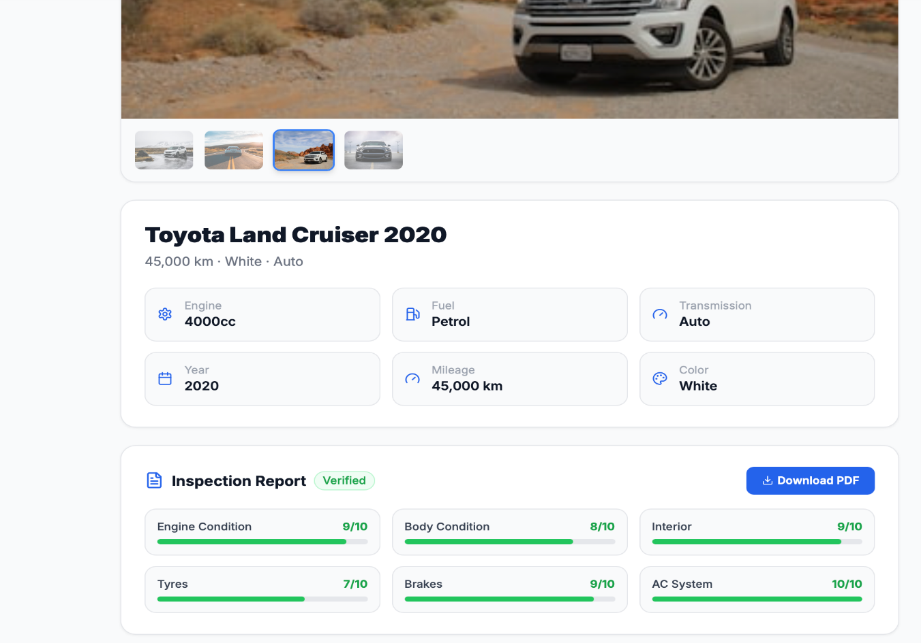
Figure 3.5.13 Auction Platform: Car Detail Page:

Admin Portal: Login Page:

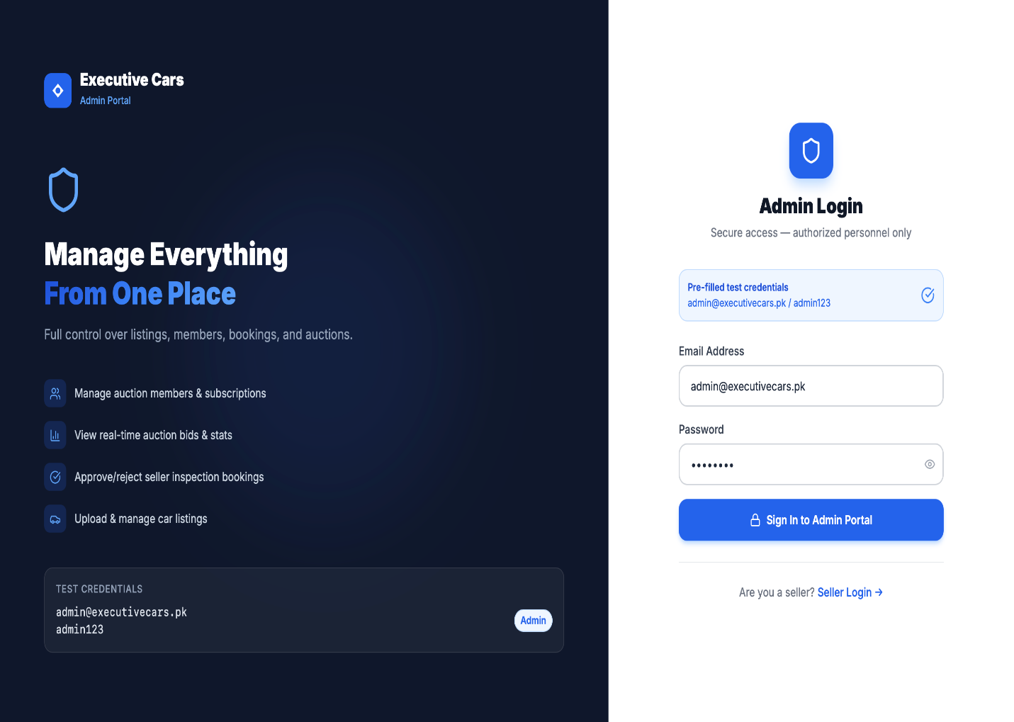
Figure 3.5.14 Admin Portal: Login Page:

Admin Portal: Users Page:

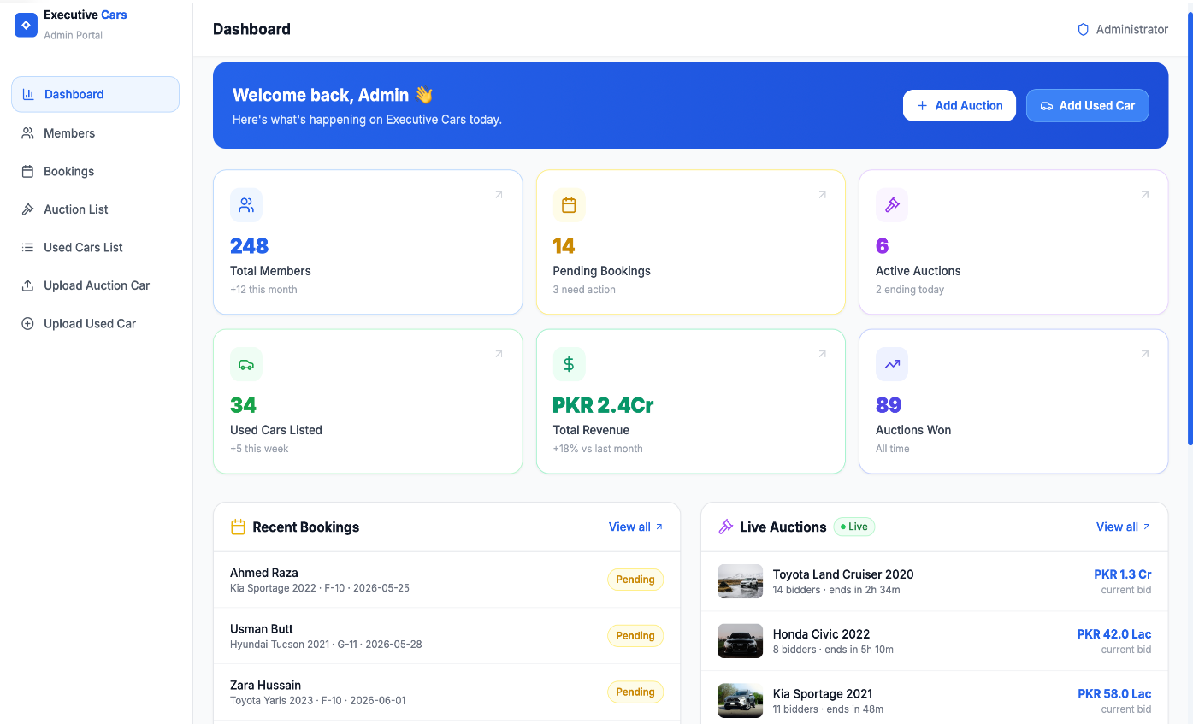
Figure 3.5.15 Admin Portal: Users Page:

Admin Portal: Inspection Bookings Page:

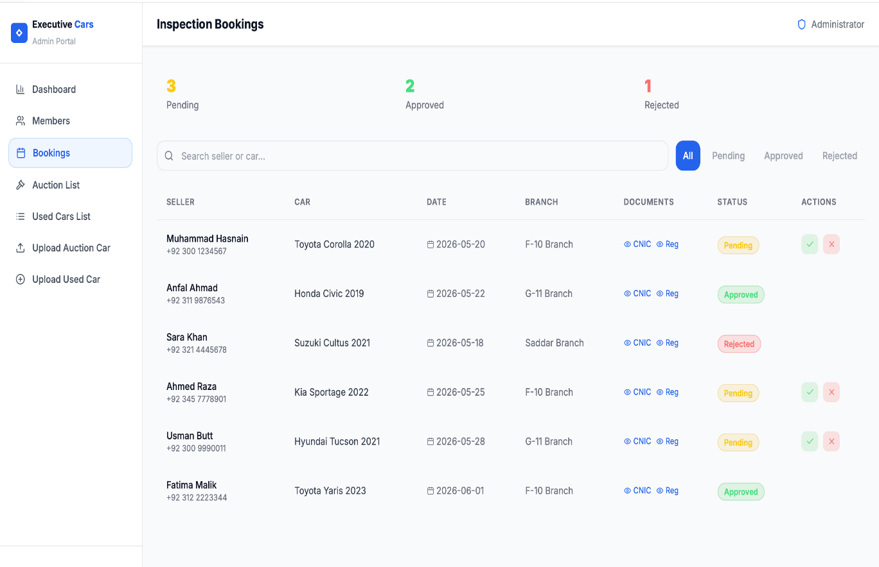
Figure 3.5.16 Admin Portal: Inspection Bookings Page:

Admin Portal: Auction List Page:

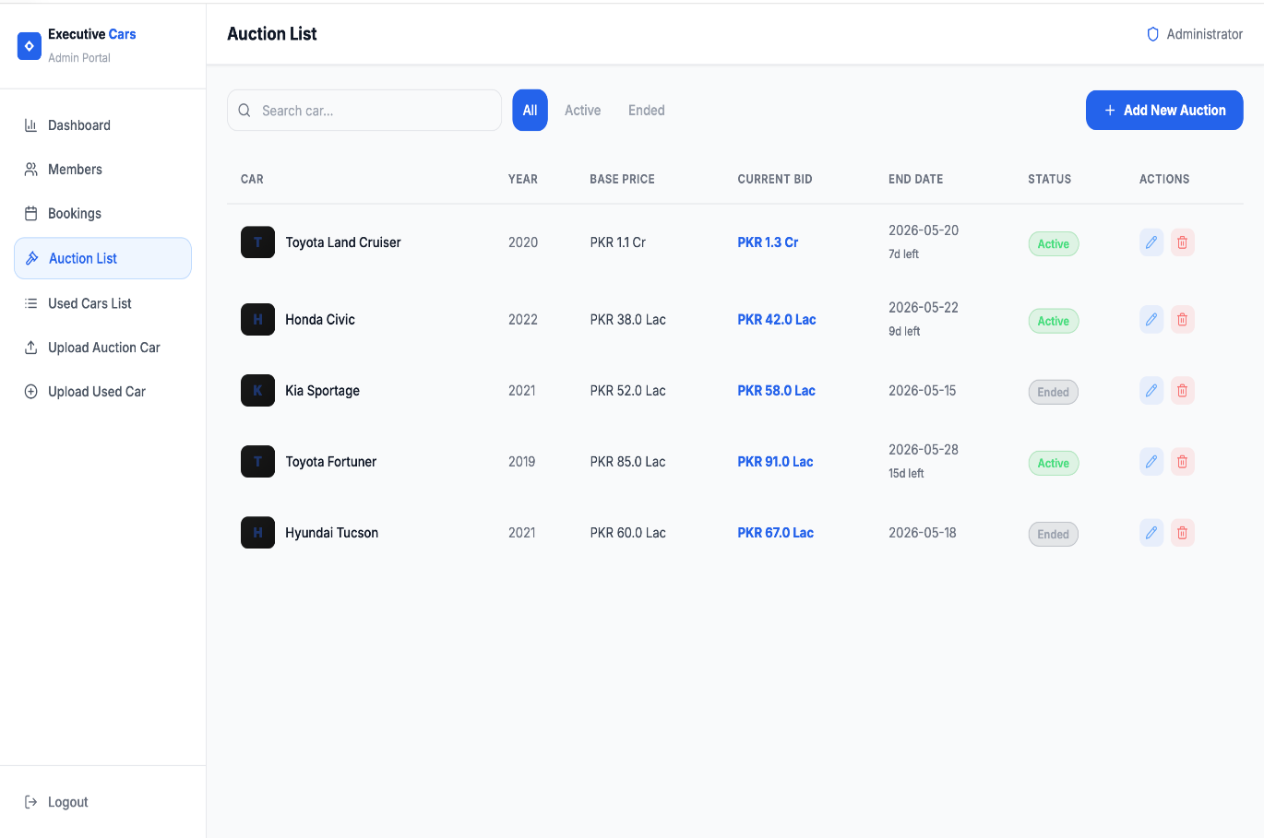
Figure 3.5.17 Admin Portal: Auction List Page:

Admin Portal: Used Cars List Page:

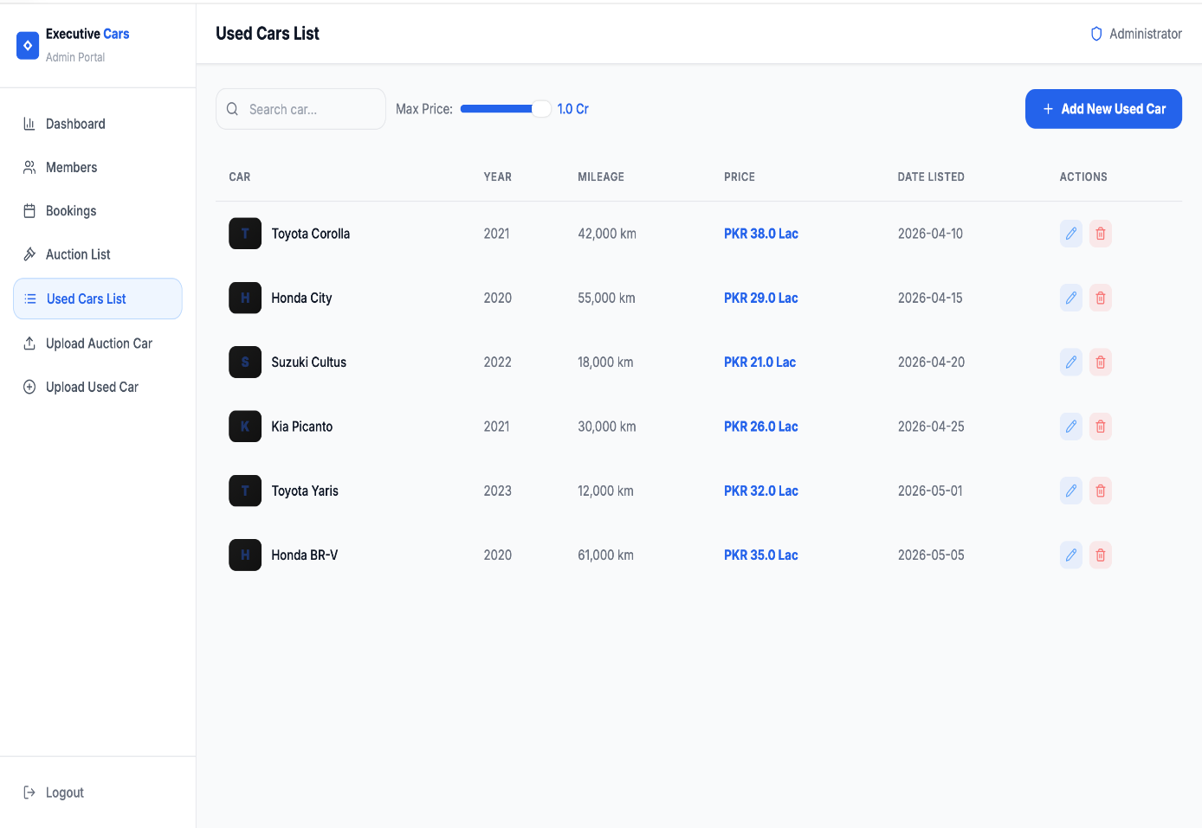
Figure 3.5.18 Admin Portal: Used Cars List Page:

Admin Portal: Upload Car Details: Auction Platform Page:

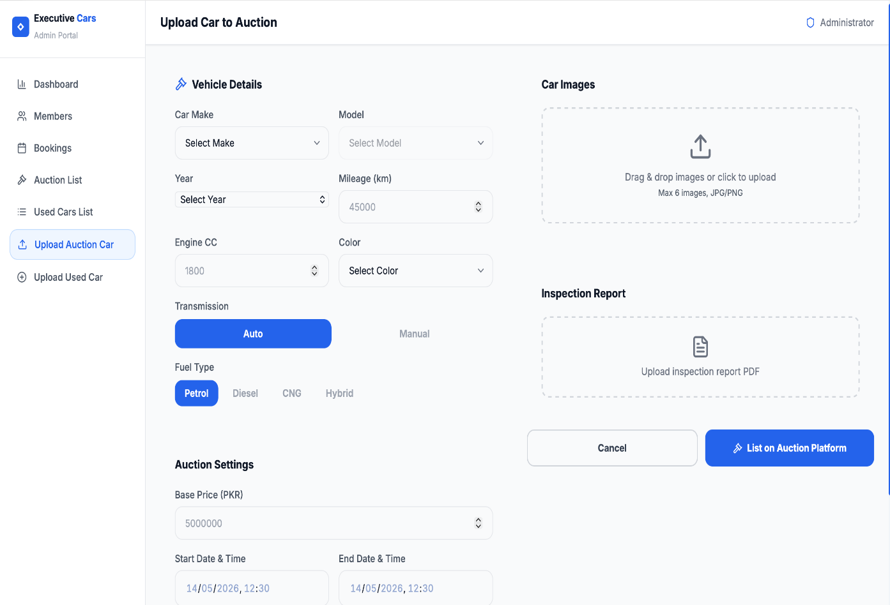
Figure 3.5.19 Admin Portal: Upload Car Details: Auction Platform Page:

Admin Portal: Upload Car Details

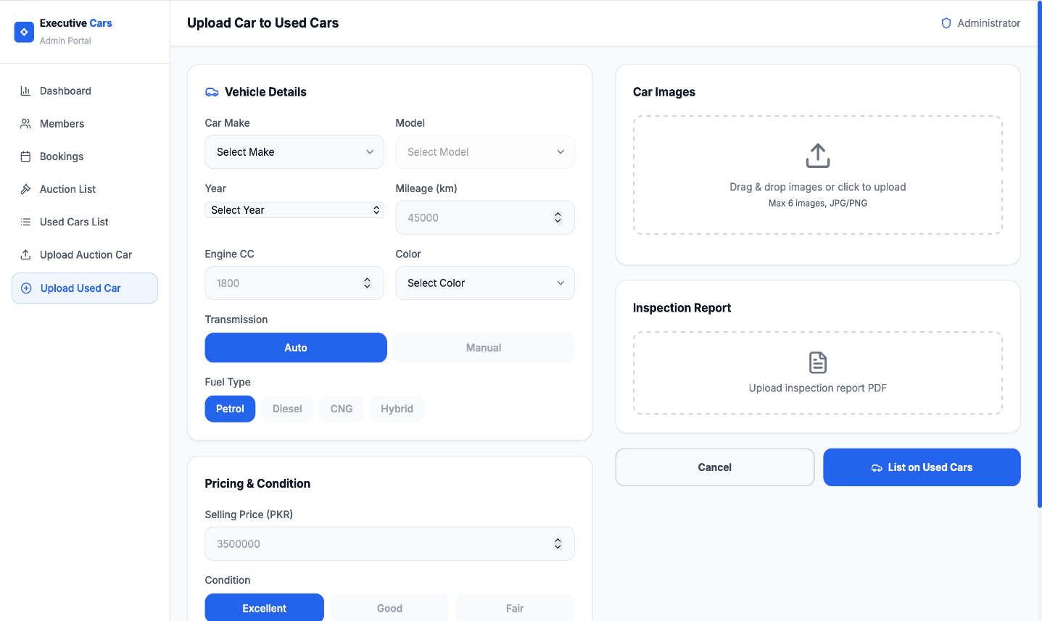
Figure 3.5.20 Admin Portal: Upload Car Details

3.6. Conclusion

This chapter outlined the system design of our auction-based car selling
platform, covering UI design, system architecture, and database modeling.
The UI screenshots demonstrated user interactions, while ERD, sequence
diagrams, and class diagrams defined data relationships and workflows.
With a structured business logic layer, efficient data access, and a scalable
infrastructure, the system ensures seamless auctions, user management,
and admin control. This foundation supports a smooth and reliable user
experience, guiding the next phase of implementation.

Chapter 4

Software Development

The Implementation phase focuses on translating the system design into a working software solution. This section provides an in-depth look at the coding standards, development environment, and key modules of the Executive Cars platform. The implementation aligns with the previously defined architecture, ensuring that the software is maintainable, scalable, and efficient.
A well-structured implementation follows best coding practices, utilizes appropriate technologies, and adheres to established design principles. This chapter outlines the core functionalities developed, including authentication, auction management, inspection booking, and AI-powered features. Additionally, it highlights the tools, frameworks, and libraries that facilitated the development process.
During implementation, unforeseen challenges such as third-party integrations, database optimizations, and performance bottlenecks were encountered. Addressing these challenges required iterative problem-solving, debugging, and refining of system components to ensure seamless operation. This chapter provides insights into how these challenges were managed while maintaining a structured and efficient development workflow.

4.1. Coding Standards

Coding standards are a set of guidelines and best practices that we followed while writing the code for our Executive Cars platform. These standards help ensure that our code is well-structured, readable, and maintainable.

4.1.1. Indentation

We followed a 2-space indentation convention for code formatting in our React components. This means that we added two spaces at the beginning of each indented line to denote code blocks, such as within functions, loops, conditionals, and other structural elements. This approach enhances code readability and maintains consistency across the code base.

4.1.2. Declaration

In the development of our platform, we followed the practice of using a single declaration per line for variables, constants, and functions. This approach involves declaring each entity on a separate line to enhance code readability and maintainability. For example, when declaring variables or constants, we dedicated one line for each declaration. Similarly, for function declarations, we also followed the practice of placing each declaration on one line. This allowed us to provide a clear and separate definition for each function, making the code more organized and easier to navigate.

4.1.3. Statement Standards

We followed statement standards to ensure clarity and readability in our code. Statements within blocks of code, such as loops and conditionals, were indented correctly. This approach helps in maintaining a clean and organized code structure, making it easier to understand the flow of the program.

4.2. Development Environment

4.2.1. Frontend: React & Tailwind CSS

React: A JavaScript library for building interactive and efficient user interfaces. It enables reusable components and fast rendering.
Tailwind CSS: A utility-first CSS framework used for responsive and customizable UI design.

4.2.2. Backend: Node.js & Express.js

Node.js: A runtime environment that allows JavaScript execution on the server side, enabling seamless frontend-backend communication.
Express.js: A lightweight Node.js framework used to create APIs and handle HTTP requests efficiently.

4.2.3. Database: MongoDB & Mongoose

MongoDB: A NoSQL database that stores data in a flexible JSONlike structure, making it easy to scale and retrieve information.
Mongoose: A MongoDB Object Data Modeling (ODM) library that provides schema-based validation and simplifies database interactions.

4.2.4. Essential Dependencies

Tailwind CSS: A utility-first CSS framework used for responsive and customizable UI design.
Axios: A promise-based HTTP client used for making API requests to fetch and send data.
Mongoose: Provides a structured way to interact with MongoDB, ensuring data consistency.

4.2.5. Development Tools

Visual Studio Code (VS Code): A feature-rich IDE used for coding, debugging, and version control.
Postman: A tool for testing API requests and responses.
Git & GitHub: Used for version control and collaboration.

4.3. Software Description:

This outlines the key modules of Executive Cars platform, highlighting the functionalities and underlying logic. Each section presents a class diagram and selected code snippets to illustrate critical implementations within the system.

4.3.1. Authentication & Authorization:

Admin Login: Handles admin authentication and session management.
User Registration & Subscription: Manages new user sign-ups, Stripe-based payments, and membership validation.

4.3.2. Car Listings & Auctions:

Auction Management: Users can view already inspected cars and place bids on preferred listings.

Bidding System: Stores and updates bid amounts, tracks highest bids, and manages auction end times.

Used Car Listings: Separate section for users to browse and buy non-auctioned cars.

4.3.3. Inspection Booking:

Inspection Booking: Allows users to schedule car inspections by selecting available time slots.

4.3.4. Admin Management:

User & Membership Management: Admins can view, delete, or manage members.
Auction Moderation: Admins can upload car listings, remove listings, and manage the auction process.

4.3.5. AI Powered Features:

AI Car Assistant: Provides users with AI-driven recommendations, answers queries about cars, and assists in auction-related decisions.
Car Price Predictor: Predicts car prices based on historical auction data, market trends, and car specifications, helping users make informed bidding and purchasing decisions.

4.3.6. Authentication & Authorization Code:

- Admin Login:
export default function AdminLoginPage() {
const navigate = useNavigate()
const { login } = useAuth()
const [form, setForm] = useState({ email: '', password: '' })
const [showPass, setShowPass] = useState(false)
const [loading, setLoading] = useState(false)
const [error, setError] = useState(false)

const handleSubmit = async (e) => {
e.preventDefault()
setLoading(true)
setError(false)
const result = await login(form.email, form.password)
if (result.success && result.role === 'admin') {
navigate('/admin/dashboard')
} else {
setError(true)
}
setLoading(false)
}

return (
<form onSubmit={handleSubmit}>
<input type="email" value={form.email}
onChange={e => setForm(f => ({ ...f, email: e.target.value }))} required />
<input type="password" value={form.password}
onChange={e => setForm(f => ({ ...f, password: e.target.value }))} required />
{error && <p>Invalid credentials. Please try again.</p>}
<button type="submit" disabled={loading}>Sign In to Admin Portal</button>
</form>
)
}

- Member login:

const ROLES = [
{ key: 'buyer', label: 'Member', icon: Gavel },
{ key: 'seller', label: 'Seller', icon: Car },
{ key: 'admin', label: 'Admin', icon: Shield },
]

export default function LoginPage() {
const { login, loginSeller, loginAuction } = useAuth()
const [role, setRole] = useState('buyer')
const [form, setForm] = useState({ email: '', password: '' })

const handleSubmit = async (e) => {
e.preventDefault()
let result
if (role === 'admin') result = await login(form.email, form.password)
else if (role === 'seller') result = await loginSeller(form.email, form.password)
else result = await loginAuction(form.email, form.password)

if (result.success) {
if (role === 'admin') navigate('/admin/dashboard')
else if (role === 'seller') navigate('/seller/dashboard')
else navigate('/auction/dashboard')
} else {
setError(true)
}
}

return (
<div>
{/* Role selector tabs */}
{ROLES.map(r => (
<button key={r.key} onClick={() => setRole(r.key)}>{r.label}</button>
))}
<form onSubmit={handleSubmit}>
<input type="email" value={form.email}
onChange={e => setForm(f => ({ ...f, email: e.target.value }))} />
<input type="password" value={form.password}
onChange={e => setForm(f => ({ ...f, password: e.target.value }))} />
<button type="submit">Sign In as {role}</button>
</form>
</div>
)
}

- Member Sign-up:

export default function AuctionSignupPage() {
const { registerMember } = useAuth()
const [form, setForm] = useState({
name: '', email: '', phone: '', password: '', confirm: '', terms: false
})

const validate = () => {
const e = {}
if (!form.name?.trim()) e.name = 'Full name is required.'
if (!form.email?.trim()) e.email = 'Email is required.'
if (!form.password || form.password.length < 8) e.password = 'Min 8 characters.'
if (form.password !== form.confirm) e.confirm = 'Passwords do not match.'
if (!form.phone?.trim()) e.phone = 'Phone number is required.'
return e
}

const handleSubmit = async (e) => {
e.preventDefault()
const errs = validate()
if (Object.keys(errs).length > 0) { setErrors(errs); return }

const result = await registerMember(form.name, form.email, form.phone, form.password)
if (result.success) {
navigate('/auction/payment') // Step 2: Stripe payment
} else {
setErrors({ email: result.message || 'Registration failed.' })
}
}

return (
<form onSubmit={handleSubmit}>
<input type="text" placeholder="Full Name" value={form.name} onChange={...} />
<input type="email" placeholder="Email" value={form.email} onChange={...} />
<input type="tel" placeholder="Phone" value={form.phone} onChange={...} />
<input type="password" placeholder="Password" value={form.password} onChange={...} />
<input type="password" placeholder="Confirm" value={form.confirm} onChange={...} />
<input type="checkbox" checked={form.terms} onChange={...} required />
<button type="submit">Proceed to Payment</button>
</form>
)
}

- Seller Sign-up

// Same LoginPage component as Member Login.
// User selects role = 'seller', which triggers loginSeller() from AuthContext.
// loginSeller calls POST /api/auth/seller/login
// On success: navigate('/seller/dashboard')

const handleSubmit = async (e) => {
e.preventDefault()
let result
if (role === 'seller') result = await loginSeller(form.email, form.password)
// ...
if (result.success) navigate('/seller/dashboard')
}

4.3.7. Car Listings & Auctions Code

- Auction Platform

export default function AuctionLiveAuctionsPage() {
const [cars, setCars] = useState([])
const [search, setSearch] = useState('')
const [filter, setFilter] = useState('All')
const [sort, setSort] = useState('ending')

// Fetch all active auction cars on mount
useEffect(() => {
api.get('/cars')
.then(res => setCars(res.data))
.catch(() => {})
.finally(() => setLoading(false))
}, [])

// Filter + sort in memory
const filtered = useMemo(() => {
return cars
.filter(a => {
const matchSearch = `${a.make} ${a.model}`
.toLowerCase().includes(search.toLowerCase())
const matchFilter =
filter === 'All' ||
(filter === 'Hot' && a.bidCount > 3) ||
(filter === 'Ending Soon' && (new Date(a.auctionEnd) - Date.now()) < 2 * 3600 * 1000)
return matchSearch && matchFilter
})
.sort((a, b) => {
if (sort === 'ending') return new Date(a.auctionEnd) - new Date(b.auctionEnd)
if (sort === 'bid-high') return b.currentBid - a.currentBid
if (sort === 'bid-low') return a.currentBid - b.currentBid
return b.bidCount - a.bidCount
})
}, [cars, search, filter, sort])

return (
<AuctionLayout>
{/* Search + filter bar */}
<input value={search} onChange={e => setSearch(e.target.value)}
placeholder="Search make or model..." />
{['All', 'Hot', 'Ending Soon'].map(f => (
<button key={f} onClick={() => setFilter(f)}>{f}</button>
))}

{/* Auction cards grid */}
<div className="grid grid-cols-3 gap-5">
{filtered.map(car => (
<Link key={car._id} to={`/auction/car/${car._id}`}>
<img src={car.images?.[0]} />
<h3>{car.make} {car.model} {car.year}</h3>
<p>Current Bid: PKR {car.currentBid.toLocaleString()}</p>
<p>{car.bidCount} bidders</p>
<CountdownTimer endsIn={timeUntil(car.auctionEnd)} />
</Link>
))}
</div>
</AuctionLayout>
)
}

- Used Car Details:

export default function UsedCarsPage() {
const [cars, setCars] = useState([])
const [search, setSearch] = useState('')
const [selectedBrands] = useState(['All'])
const [priceRange] = useState([0, 10000000])
const [mileageMax] = useState(100000)
const [transmission] = useState('All')
const [selectedFuels] = useState([])
const [sort, setSort] = useState('newest')
const [page, setPage] = useState(1)
const PER_PAGE = 6

// Fetch all available used cars on mount
useEffect(() => {
api.get('/products')
.then(res => setCars(res.data))
.catch(() => {})
.finally(() => setLoading(false))
}, [])

// Client-side filtering
const filtered = useMemo(() => cars.filter(c => {
if (!selectedBrands.includes('All') && !selectedBrands.includes(c.make)) return false
if (c.price > priceRange[1]) return false
if (c.km > mileageMax) return false
if (transmission !== 'All' && c.transmission !== transmission) return false
if (selectedFuels.length > 0 && !selectedFuels.includes(c.fuel)) return false
if (search && !`${c.make} ${c.model}`.toLowerCase().includes(search)) return false
return true
}).sort((a, b) => {
if (sort === 'price-asc') return a.price - b.price
if (sort === 'price-desc') return b.price - a.price
if (sort === 'km-asc') return a.km - b.km
return b.year - a.year
}), [cars, selectedBrands, priceRange, mileageMax, transmission, selectedFuels, search, sort])

// Pagination
const paginated = filtered.slice((page - 1) * PER_PAGE, page * PER_PAGE)

return (
<div>
<input value={search} onChange={e => setSearch(e.target.value)}
placeholder="Search make or model..." />
{/* Filter sidebar and car grid */}
{paginated.map(car => (
<div key={car._id}>
<img src={car.images?.[0]} />
<h3>{car.make} {car.model}</h3>
<p>PKR {car.price.toLocaleString()}</p>
<Link to={`/used-cars/${car._id}`}>View</Link>
</div>
))}
</div>
)
}

4.3.8. Inspection Booking Code

- Inspection Booking:

const branches = [
'Rawalpindi - Stadium Road Branch',
'Rawalpindi - Saddar Branch',
]

export default function BecomeSellerPage() {
const [step, setStep] = useState(1) // 1 = Personal, 2 = Vehicle, 3 = Docs+Date
const [showOTP, setShowOTP] = useState(false)
const [otp, setOtp] = useState(['','','','','',''])
const [form, setForm] = useState({ name:'', phone:'', cnic:'', email:'',
make:'', model:'', year:'', mileage:'', engine:'',
cnicFile:null, regFile:null, date:'', branch:'' })

// Step 3 submit — sends OTP to seller email
const handleSubmit = async (e) => {
e.preventDefault()
if (step < 3) { setStep(s => s + 1); return }
await api.post('/bookings/send-otp', { email: form.email })
setShowOTP(true)
}

// OTP verified — submit full booking with files
const handleVerifyOtp = async () => {
await api.post('/bookings/verify-otp', {
email: form.email, otp: otp.join('')
})
const fd = new FormData()
fd.append('name', form.name); fd.append('email', form.email)
fd.append('phone', form.phone); fd.append('carMake', form.make)
fd.append('carModel', form.model); fd.append('carYear', form.year)
fd.append('mileage', form.mileage); fd.append('engineCC', form.engine)
fd.append('date', form.date); fd.append('branch', form.branch)
if (form.cnicFile) fd.append('cnicImage', form.cnicFile)
if (form.regFile) fd.append('regDoc', form.regFile)
await api.post('/bookings', fd, { headers: { 'Content-Type': 'multipart/form-data' } })
navigate('/booking-confirmed', {
state: { date: form.date, branch: form.branch, email: form.email }
})
}

return (
<form onSubmit={handleSubmit}>
{step === 1 && <{/* Personal info fields */}>}
{step === 2 && <{/* Vehicle detail fields */}>}
{step === 3 && <{/* File upload + date + branch */}>}
<button type="submit">{step < 3 ? 'Next Step' : 'Book Inspection'}</button>
</form>
)
}

4.3.9. Admin Management Code

- Auction & Used Cars Listing Auction Page (Update , Delete, Add):

export default function AdminAuctionListPage() {
const [auctions, setAuctions] = useState([])
const [deleteTarget, setDeleteTarget] = useState(null)
const [editTarget, setEditTarget] = useState(null)

// Load all auction cars
useEffect(() => {
api.get('/admin/cars').then(res => setAuctions(res.data)).catch(() => {})
}, [])

// DELETE — confirmed via modal
const confirmDelete = async () => {
await api.delete(`/admin/cars/${deleteTarget._id}`)
setAuctions(prev => prev.filter(a => a._id !== deleteTarget._id))
setDeleteTarget(null)
}

// UPDATE — edits make, model, year, basePrice, auctionEnd
const saveEdit = async () => {
const payload = {
make: editTarget.make, model: editTarget.model,
year: Number(editTarget.year),
basePrice: Number(editTarget.basePrice),
auctionEnd: editTarget.auctionEnd,
}
const { data } = await api.put(`/admin/cars/${editTarget._id}`, payload)
setAuctions(prev => prev.map(a => a._id === editTarget._id ? data : a))
setEditTarget(null)
}

return (
<AdminLayout>
{/* Table rows */}
{auctions.map(a => (
<tr key={a._id}>
<td>{a.make} {a.model}</td>
<td>
<button onClick={() => setEditTarget(a)}>Edit</button>
<button onClick={() => setDeleteTarget(a)}>Delete</button>
</td>
</tr>
))}

{/* Delete confirmation modal */}
{deleteTarget && (
<div>
<p>Remove {deleteTarget.make} {deleteTarget.model}?</p>
<button onClick={() => setDeleteTarget(null)}>Cancel</button>
<button onClick={confirmDelete}>Delete</button>
</div>
)}

{/* Edit slide-in panel */}
{editTarget && (
<div>
{['make','model','year','basePrice','auctionEnd'].map(key => (
<input key={key} value={editTarget[key]}
onChange={e => setEditTarget(p => ({ ...p, [key]: e.target.value }))} />
))}
<button onClick={saveEdit}>Save Changes</button>
</div>
)}
</AdminLayout>
)
}

- Auction & Used Cars Listing Used Cars Page (Update , Delete, Add):

export default function AdminUsedCarsListPage() {
const [cars, setCars] = useState([])
const [deleteTarget, setDeleteTarget] = useState(null)
const [editTarget, setEditTarget] = useState(null)

useEffect(() => {
api.get('/admin/products').then(res => setCars(res.data)).catch(() => {})
}, [])

// DELETE
const confirmDelete = async () => {
await api.delete(`/admin/products/${deleteTarget._id}`)
setCars(prev => prev.filter(c => c._id !== deleteTarget._id))
setDeleteTarget(null)
}

// UPDATE — edits make, model, year, km, price
const saveEdit = async () => {
const payload = {
make: editTarget.make, model: editTarget.model,
year: Number(editTarget.year),
km: Number(editTarget.km),
price: Number(editTarget.price),
}
const { data } = await api.put(`/admin/products/${editTarget._id}`, payload)
setCars(prev => prev.map(c => c._id === editTarget._id ? data : c))
setEditTarget(null)
}

return (
<AdminLayout>
{/* Table + edit/delete buttons — same pattern as auction list */}
</AdminLayout>
)
}

4.3.10. AI Powered Features Code:

- AI Car Assistant:

const WELCOME = {
id: 'welcome', role: 'assistant',
content: "Hi! I'm the Executive Cars AI assistant. Ask me anything about buying, selling, auctions, or pricing.",
}

export default function AIAssistantWidget() {
const [open, setOpen] = useState(false)
const [messages, setMessages] = useState([WELCOME])
const [input, setInput] = useState('')
const [loading, setLoading] = useState(false)

const send = async () => {
const text = input.trim()
if (!text || loading) return

const userMsg = { id: Date.now(), role: 'user', content: text }
const next = [...messages, userMsg]
setMessages(next)
setInput('')
setLoading(true)

try {
// Filter out the welcome message before sending to API
const payload = next
.filter(m => m.id !== 'welcome')
.map(({ role, content }) => ({ role, content }))

const { data } = await api.post('/chat', { messages: payload })
setMessages(prev => [
...prev,
{ id: Date.now() + 1, role: 'assistant', content: data.reply }
])
} catch {
setMessages(prev => [...prev, {
id: Date.now() + 1, role: 'assistant',
content: "Sorry, I'm having trouble. Please email info@executivecars.pk"
}])
} finally {
setLoading(false)
}
}

return (
<div className="fixed bottom-6 right-6 z-50">
{open && (
<div> {/* Chat window */}
{messages.map(msg => (
<div key={msg.id} className={msg.role === 'user' ? 'text-right' : 'text-left'}>
{msg.content}
</div>
))}
{loading && <div>AI is typing...</div>}
<input value={input} onChange={e => setInput(e.target.value)}
onKeyDown={e => e.key === 'Enter' && send()}
placeholder="Ask me anything…" />
<button onClick={send}>Send</button>
</div>
)}
<button onClick={() => setOpen(o => !o)}>Chat</button>
</div>
)
}

- Car Price Predictor:

export default function PricePredictorPage() {
const [form, setForm] = useState({
brand: '', model: '', year: 2020, mileage: 30000,
engine: 1300, transmission: 'Auto', fuel: 'Petrol'
})
const [result, setResult] = useState(null)
const [confidence, setConfidence] = useState(87)

const handlePredict = async (e) => {
e.preventDefault()
setLoading(true)
try {
const { data } = await api.post('/predict', { ...form, make: form.brand })
setResult(data.predicted)
setConfidence(data.confidence != null ? Math.round(data.confidence * 100) : 87)
} catch {
// Local fallback formula if backend is unreachable
setResult(localEstimate(form))
setConfidence(87)
}
setLoading(false)
}

return (
<form onSubmit={handlePredict}>
<select value={form.brand} onChange={e => setForm(f => ({ ...f, brand: e.target.value }))}>
{brands.map(b => <option key={b} value={b}>{b}</option>)}
</select>
<select value={form.model} onChange={e => setForm(f => ({ ...f, model: e.target.value }))}>
{(models[form.brand] || []).map(m => <option key={m} value={m}>{m}</option>)}
</select>
<input type="range" min={2010} max={2025} value={form.year}
onChange={e => setForm(f => ({ ...f, year: +e.target.value }))} />
<input type="range" min={0} max={200000} value={form.mileage}
onChange={e => setForm(f => ({ ...f, mileage: +e.target.value }))} />
<button type="submit">Predict Price</button>
</form>
)
}

4.4. Conclusion:

To conclude, the Car Auction Platform integrates various features to enhance user experience and streamline auction processes. The Admin Management
System enables efficient handling of user memberships and auction moderation, allowing admins to oversee listings and member activities. The AI Car Assistant provides intelligent recommendations and assistance, while the Car Price Predictor empowers users with data-driven price estimations, improving decision-making in auctions. These functionalities collectively create a robust and user-friendly platform that facilitates secure, informed, and efficient car trading.

